**CHAROTAR UNIVERSITY OF SCIENCE & TECHNOLOGY**

FACULTY OF TECHNOLOGY AND ENGINEERING

**Devang Patel Institute of Advance Technology & Research**

DEPARTMENT OF COMPUTER SCIENCE & ENGINEERING

**CE247 Web Technologies**

**Semester:** IV

**Academic Year :** 2019-20

**PRACTICAL LIST**

# Part–1 ( HTML 4.01 )

|  |  |  |  |  |
| --- | --- | --- | --- | --- |
| **Sr.**  **No.** | **Practical** | **Date** | **Page No.** | **Remark** |
| **1.** | Study following HTML4.01 tags along with necessary attributes: Doctype and Basic structure tags, Heading tags, Meta tags, Paragraphs,  Text Formatting tags, Link tags, List tag, Image, Table, Form, Iframe, HTML Encode |  |  |  |
| **2.** | Create Personal Home page using all above HTML tags. Create layout of web page using div tag. |  |  |  |

# Part–2 ( HTML 5 )

|  |  |  |  |  |
| --- | --- | --- | --- | --- |
| **Sr.**  **No.** | **Practical** | **Date** | **Page No.** | **Remark** |
| **1.** | Study and Implement new tags which are added into HTML5 along with required attributes. |  |  |  |
| **2.** | Create registration form for social networking website using HTML5 form tag and attributes. Apply necessary validation using  HTML5 pattern attributes which Specifies a regular expression to check th input value against. |  |  |  |
| **3.** | Create different graphics using HTML CANVAS. Apply required properties and methods. |  |  |  |
| **4.** | Study HTML5 APIs. |  |  |  |

# Part–3 ( CSS2.0 )

|  |  |  |  |  |
| --- | --- | --- | --- | --- |
| **Sr.**  **No.** | **Practical** | **Date** | **Page No.** | **Remark** |
| **1.** | Implement following properties of CSS 2.0.   1. Background, Font and Text 2. Margin, Padding and Border (Box Model) 3. Table 4. Display 5. Position 6. Floating 7. Pseudo elements |  |  |  |
| **2.** | Create Cascading menu using CSS2.0. |  |  |  |
| **3.** | Create an overlay div with CSS2.0 |  |  |  |

# Part–4 ( CSS3.0 )

|  |  |  |  |  |
| --- | --- | --- | --- | --- |
| **Sr.**  **No.** | **Practical** | **Date** | **Page No.** | **Remark** |
| **1.** | Implement Back grounds and Borders properties using CSS 3.0 |  |  |  |
| **2.** | Implement Text Effects properties using CSS 3.0 |  |  |  |
| **3.** | Implement 2Dand 3D Transform properties using CSS 3.0 |  |  |  |
| **4.** | Implement Animations properties using CSS 3.0 |  |  |  |
| **5.** | Implement Multiple Column Layout properties using CSS 3.0 |  |  |  |
| **6.** | Implement User Interface properties using CSS 3.0 |  |  |  |
| **7.** | Refer Practical 2 and apply flexible layout to your page. |  |  |  |

# Part–5 ( Java Scripts & DOM )

|  |  |  |  |  |
| --- | --- | --- | --- | --- |
| **Sr.**  **No.** | **Practical** | **Date** | **Page No.** | **Remark** |
| **1.** | Create JavaScript function for basic arithmetic operations (Addition, Subtraction, Multiplication and Division). Create proper design layout which asks two numbers to enter from user and display result of respective operation on clicking respective button. |  |  |  |
| **2.** | Create HTML form like any registration form with all necessary controls. Write a JavaScript which retrieve possible value from all controls and display on webpage. Use some style rules to format |  |  |  |
| **3.** | Create JavaScript for form Validation for following tasks   1. Text box must have required value. 2. Textbox must accept only letters. 3. Textbox must accept only numbers. 4. Textbox must contain character in the range of 6-12. 5. Compare entered password and confirmed password. 6. Check whether radio button, check box or dropdown box has selected or not. 7. Email validation. 8. Mobile number validation.   Design proper HTML form and perform all above task. |  |  |  |
| **4.** | Create Dynamic table using DOM which perform following tasks:   * Add new Row and Column * Delete Row and cell. |  |  |  |

# Part–6 ( BASICJQUERY )

|  |  |  |  |  |
| --- | --- | --- | --- | --- |
| **Sr.**  **No.** | **Practical** | **Date** | **Page No.** | **Remark** |
| **1.** | Implement following tasks using jQuery:   * Sliding page elements * Hiding and Showing elements * Fading elements * Toggling elements * Stopping Effects |  |  |  |
| **2.** | Create Animated Login form. |  |  |  |

# Part–7 ( BASICJ PHP )

|  |  |  |  |  |
| --- | --- | --- | --- | --- |
| **Sr.**  **No.** | **Practical** | **Date** | **Page No.** | **Remark** |
| **1.** | Installation and configuration of WAMP/XAMPP |  |  |  |
| **2.** | Study and demonstrate php syntax, data type, variable, function, array, super global variable and form. |  |  |  |
| **3.** | Study and demonstrate MySQL connection and CRUID operations with php. |  |  |  |

**CHAROTAR UNIVERSITY OF SCIENCE AND TECHNOLOGY**

**FACULTY OF TECHNOLOGY & ENGINEERING**

**DEVANG PATEL INSTITUTE OF ADVANCED TECHNOLOGY AND RESEARCH**

**DEPARTMENT OF COMPUTER SCIENCE AND ENGINEERING**

|  |  |
| --- | --- |
| **Subject Name & Code : CE247 Web Technologies** | **Semester: IV** |

**Course Outcomes:**

Upon completion of this course, students will be able to do the following:

* Students will able to develop static and dynamic website and web base applications.
* Students will use knowledge of the subject in higher semester for subjects like Advance Java Technology and .Net Web technology and also for Project development.

|  |  |  |  |
| --- | --- | --- | --- |
| **Sr.no** | **Practical Name** | **Co1** | **Co2** |
| 1 | Part 1: HTML 4.0 | **√** |  |
| 2 | Part 2: HTML 5.0 | **√** | **√** |
| 3 | Part 3: CSS 2.0 | **√** |  |
| 4 | Part 4: CSS 3.0 | **√** | **√** |
| 5 | Part 5: JavaScript &  DOM | **√** | **√** |
| 6 | Part 6: Basic jQuery | **√** | **√** |
| 7 | Part 7: Basic PHP | **√** | **√** |

**PART – 1 ( HTML 4.01 )**

**PRACTICAL - 1**

**AIM** : Study following HTML4.01 tags along with necessary attributes:Doctype and Basic structure tags, Heading tags, Meta tags, Paragraphs,Text Formatting tags, Link tags, List tag, Image, Table, Form, Iframe,HTML Encode.

**PROGRAM:**

<!doctype html>

<html>

    <head>

        <meta charset="utf-8">

        <link rel="stylesheet" href="p1.css">

        <title>My Table</title>

    </head>

    <body>

                <form name="f1">

                    <fieldset>

                        <legend>Registration Form</legend>

                    <div>

                        <p>First Name :<input type="text" name="firstname"  placeholder="Enter the first name"/></p>

                    </div>

                    <div>

                        <p>Last Name :<input type="text" name="lastname" placeholder="Enter the last name" /></p>

                    </div>

                    <div>

                        <p>User ID :<input type="text" name="uid" placeholder="Enter the User ID" /></p>

                    </div>

                    <div>

                        <p>Password :<input type="password" name="firstname" placeholder="Enter the password" /></p>

                    </div>

                    <div>

                        <p>Gender :<input type="radio" name="radio1" value="male" checked />Male<input type="radio" name="radio1" value="female" />Female</p>

                    </div>

                    <div>

                        <p>Hobby :<input type="checkbox" name="radio1" value="swiming" />Swiming<input type="checkbox" name="radio1" value="reading" />Reading<input type="checkbox" name="radio1" value="writing" />writing</p>

                    </div>

                    <div>

                        <p>Address :<textarea row=6 column=50 placeholder="Enter the Address"></textarea></p>

                    </div>

                    <div>

                        <button >SUBMIT</button>

                        <button type="reset">RESET</button>

                    </div>

                    </fieldset>

                </form>

    </body>

</html>

CSS CODE

legend {

    color: white;

  text-shadow: 1px 1px 2px black, 0 0 25px blue, 0 0 5px darkblue;

}

form{

    width: 25%;

}

**OUTPUT :**

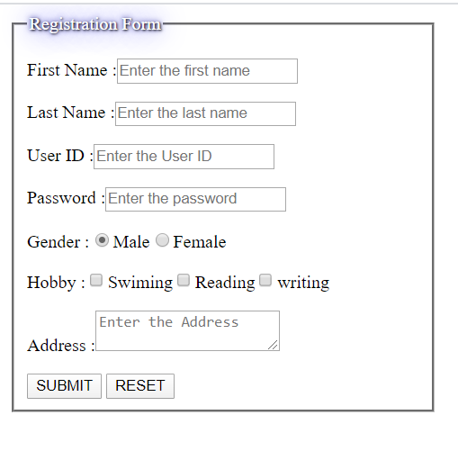

**CONCLUSION:**

Here in this practical, we learned about the basic tags of HTML.

**PRACTICAL - 2**

**AIM:** Create Personal Home page using all above HTML tags. Create layout of web page using div tag.

**PROGRAM:**

<!DOCTYPE html>

<html>

<head>

    <link rel="stylesheet" href="p2.css">

    <link href="https://fonts.googleapis.com/css?family=Roboto&display=swap" rel="stylesheet">

    <link rel="icon" type="image/x-icon" href="dep.png"/>

    <title>My Website</title>

</head>

<body>

<div>

<!--<a href="#bottom" >Go to bottom</a>

<a href="mailto:kkakadiya153@gmAail.com;" >Mail</a> -->

    <div style="vertical-align:top" style="background-color:lightblue;">

        <p align="center" ><imgsrc='download.png' alt='image is not avaliable' style="width:300px; height:150px" />

        <h1 align="center" style="font-size:25px;">Charotar University of Science and Technology</h1></p>

        <hr>

    </div>

    <div>

        <h3><u>About us</u></h3>

        <ul><li><p align="justify">Charotar University of Science and Technology is established under the Gujarat Act No. 8 of 2009, Government of Gujarat. University Grants Commission has empowered CHARUSAT to award Degrees under Section 22 of UGC Act 1956. </p></ul>

    </div>

    <div>

        <h3><u>CHARUSAT at a glance</u></h3>

        <ul>

            <li><p align="justify">Charotar University of Science and Technology (CHARUSAT) has been conceived by Shri Charotar Moti Sattavis Patidar Kelavani Mandal to make Charotar – the Land of Sardar Patel the Global Education Hub. Kelavani Mandal is a premier education trust of India. It has an ancestry of social service of more than 125 years old social organization.</p>

            <li><p align="justify">CHARUSAT has been established under Gujarat Private University Act No. 8 of 2009. It is empowered to confer degrees under Section 22 of UGC Act 1956. It is the first State University getting “A” Grade in Gujarat in the first cycle by National Assessment and Accreditation Council, NAAC, Bangalore.</p>

            <li><p align="justify">Presently, CHARUSAT offers 72 programs from Undergraduate to Doctoral (Ph D) under the tutelage of 9 Institutes, 6 Faculties, 4 Major Centres/ Cells, employee strength of 550, student strength of 7500 and a Capital Outlay of INR 150 Crores. The programs are offered in the allied disciplines of Technology & Engineering, Pharmacy, Computer Applications, Management Studies, Applied Sciences, Nursing, Physiotherapy, and other Paramedical Sciences.</p>

            <li><p align="justify">All programs are semester based and are delivered in English Medium. Credit and Grading Systems are followed for Teaching, Learning and Evaluation. Curriculum and Pedagogy correspond with societal needs. Industrial Visits, Study Tours, Interactive IT enabled Teaching Practice, Project / Case / Task Based Learning, Blended Learning, and Expert Lectures form an integral part of innovative pedagogy at CHARUSAT.</p>

            <li><p align="justify">The Iron Man of India, Sardar Vallabhbhai Patel believed, “Education without character is futile”. CHARUSAT proudly follows this spirit. It also follows founding High Moral Values like Honesty, Integrity, Transparency, Fairness, Equity, and Accountability. </p>

        </ul>

    </div>

    <div style="vertical-align:topfloat:right">

        <div style="float:left">

            <h3>Quick Links

            <ul>

            <li><a href="https://www.charusat.ac.in/CSPIT/" style="font-size:15px;">CSPIT</a><br>

            <li><a href="https://www.charusat.ac.in/DPIATR/" style="font-size:15px;">DEPSTAR</a><br>

            <li><a href="https://www.charusat.ac.in/RPCP/" style="font-size:15px;">RPCP</a><br>

            <li><a href="https://www.charusat.ac.in/CMPICA/" style="font-size:15px;">CMPICA</a><br>

            <li><a href="https://www.charusat.ac.in/PDPIAS/" style="font-size:15px;">PDPIAS</a><br></h3>

            <a href="#top" name="bottom" >Back to top</a><br>

            <a href="pr1.html" name="bottom" > Registration form</a>

            <!--<iframe src="index.html" width="1300px" align="center" height="250px">

                <p>Your browser does not support iframes.</p>

            </iframe> -->

            </ul>

        </div>

        <div style="float:right;margin:50px 30px 0 0">

            <a href="https://www.charusat.ac.in/CSPIT/" /><img src='cspitlogo.png' alt='image is not avaliable' style="width:180px; height:150px" />

            <a href="https://www.charusat.ac.in/DPIATR/" /><img src='depstarlogo.png' alt='image is not avaliable' style="width:180px0px; height:150px" />

            <a href="https://www.charusat.ac.in/RPCP/" /><img src='rpcp.jpg' alt='image is not avaliable' style="width:180px0px; height:150px" />

            <a href="https://www.charusat.ac.in/CMPICA/" /><img src='cmpica.jpg' alt='image is not avaliable' style="width:180pxpx; height:150px" />

            <a href="https://www.charusat.ac.in/PDPIAS/" /><img src='pdpias.jpg' alt='image is not avaliable' style="width:180px; height:150px" />

            <!--<a href="https://www.charusat.ac.in/PDPIAS/" /><imgsrc='200w_s.gif' alt='image is not avaliable' style="width:180px; height:150px" /> -->

        </div>

    </div>

</div>

</body>

</html>

CSS CODE

*

{

    font-family: 'Roboto', sans-serif;

}

h1 {

  text-shadow: 2px 2px 5px blue;

}

**OUTPUT:**

**CONCLUSION:**

We created our homepage by using the HTML tags.

**PART – 2 ( HTML 5 )**

**PRACTICAL - 1**

**AIM:** Study and Implement new tags which are added into HTML5 along with required attributes.

**PROGRAM:**

<!DOCTYPE html>

<html>

<head>

<style type="text/css">

footer

{

clear: both;

}

</style>

</head>

<body>

<header>

<h1>Most important heading here</h1>

</header>

<p>The <abbr title="World Health Organization">WHO</abbr> was founded in 1948. Abbr tag</p>

<form >

Datalist

<input list="browsers" name="browser">

<datalist id="browsers">

<option value="Internet Explorer">

<option value="Firefox">

<option value="Chrome">

<option value="Opera">

<option value="Safari">

</datalist>

<input type="submit">

</form>

Downloading progress:

<progress value="23" max="100">

</progress>

<section>

<article>

<h1>Google Chrome</h1>

<p>Google Chrome is a free, open-source web browser developed by Google, released in 2008.</p>

</article>

</section>

<footer>

This is footer

</footer>

</body>

</html>

**OUTPUT:**

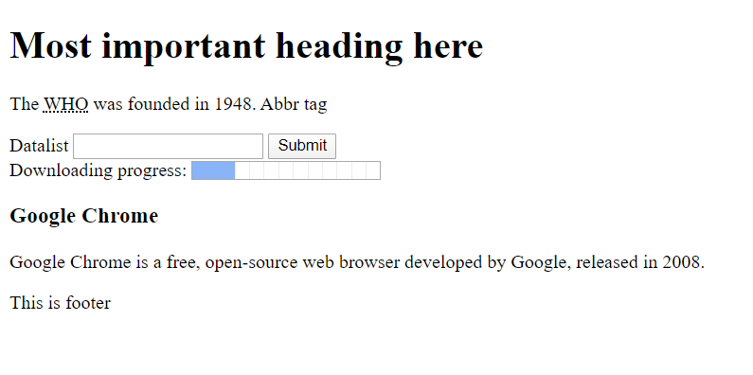**CONCLUSION:**

In this practical we learn implementation of new tag which are added into HTML5.

**PRACTICAL - 2**

**AIM:** Create registration form for social networking website using HTML5 form tag and attributes. Apply necessary validation using HTML5 pattern attributes which Specifies a regular expression to check the input value against.

**PROGRAM:**

<!DOCTYPE html>

<html>

<head>

<title>Html form</title>

<style type="text/css">

body{

background-color:#ADD8E6;

}

fieldset{

border:1px solid red;

}

</style>

</head>

<body>

<div>

<center>

<fieldset style="width: 280px;">

<legend>Student Registration</legend>

<form>

<table>

<tr>

<td>

<label>User name </label>

</td>

<td>

<input type="text" name="username" id="username" pattern="[a-zA-Z0-9]{10}" title="Enter your name" required></input>

</td>

</tr>

<tr>

<td>

<label>Password </label>

</td>

<td>

<input type="password" name="password" id="password" pattern="[a-zA-Z0-9]{10}" title="Enter your password" required></input>

</td>

</tr>

<tr>

<td>

<label>Blog url</label>

</td>

<td>

<input type="url" name="link" id="link" required></input>

</td>

</tr>

<tr>

<td>

<label>Email</label>

</td>

<td>

<input type="email" name="email" id="email" pattern="[a-zA-Z0-9]+@[a-zA-Z0-9]{3}+\.[a-z]{2,3}" title="Enter your email id" required></input>

</td>

</tr>

<tr>

<td>

<label>Date</label>

</td>

<td>

<input type="date" pattern="[0-9]{2}-[a-z]{3}-[0-9]{4}" required></input>

</td>

</tr>

<tr>

<td>

<label>Contect number </label>

</td>

<td>

<input type="tel" pattern="[1-9]{3}-[0-9]{3}-[0-9]{4}" required></input>

</td>

</tr>

<tr>

<td>

<label>Country </label>

</td>

<td>

<input type="text" list="d11" required></input>

<datalist id="d11">

<option>India</option>

<option>China</option>

<option>US</option>

<option>UK</option>

</datalist>

</td>

</tr>

<tr>

<td>

<label>Color</label>

</td>

<td>

<input type="color" required></input>

</td>

</tr>

<tr>

<td>

<label>Progressbar</label>

</td>

<td>

<progress max="100" value="25"></progress>

</td>

</tr>

<tr>

<td>

<label>Range</label>

</td>

<td>

<input type="range" name="range" min="0" max="50">

</td>

</tr>

<tr>

<td>

<label>Meter </label>

</td>

<td>

<meter min="0" max="100" low="33" high="66" value="32" optimum="100"> At </meter>

</td>

</tr>

<tr>

<td>

<label>File</label>

</td>

<td>

<input type="file" name="Search"></input>

</td>

</tr>

<tr>

<td>

<label>Search </label>

</td>

<td>

<input type="search" name="Search"></input><input type="button" name="go" value="Go"></input>

</td>

</tr>

<tr>

<td colspan=2>

<!--<input type="submit" name="submit" value="Submit"> -->

<input type="image" src="download1.jfif" width="200px">

</td>

</tr>

</table>

</form>

</fieldset>

</center>

<center>

<fieldset style="width: 280px;">

<legend>Student Login</legend>

<form>

<table>

<tr>

<td>

<label>User name </label>

</td>

<td>

<input type="text" name="username" id="username" pattern="[a-zA-Z0-9]{10}" title="Enter your name" required></input>

</td>

</tr>

<tr>

<td>

<label>Password </label>

</td>

<td>

<input type="password" name="password" id="password" pattern="[a-zA-Z0-9]{10}" title="Enter your password" required></input>

</td>

</tr>

<tr>

<td colspan=2>

<!--<input type="submit" name="submit" value="Submit"> -->

<center><input type="image" src="download.jfif" width="200px"></center>

</td>

</tr>

</table>

</form>

</fieldset>

</center>

</body>

</html>

**OUTPUT:**

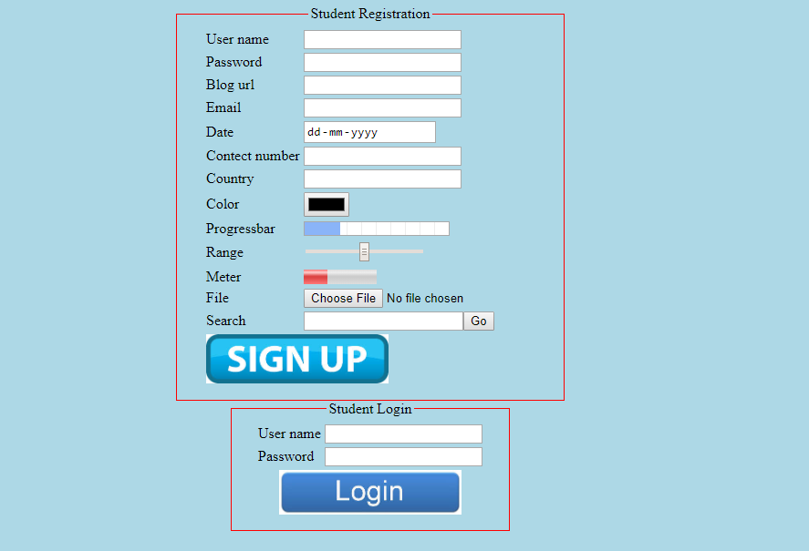

**CONCLUSION:**

In this practical we performvalidation usingHTML5 pattern attributes which Specifies a regular expression to check the input value against.

**PRACTICAL - 3**

**AIM:** Create different graphics using HTML CANVAS. Apply required properties and methods.

**PROGRAM:**

<!DOCTYPE html>

<html>

<head>

<title></title>

<style type="text/css">

canvas{

border: 2px solid black;

}

</style>

<script type="text/javascript">

function line() {

var canvas=document.getElementById('mycanvas');

var context=canvas.getContext('2d');

context.clearRect(0, 0, canvas.width, canvas.height);

context.strokeStyle="red";

context.moveTo(10,10);

context.lineTo(1505,10);

context.stroke();

}

function rectangle() {

var canvas=document.getElementById('mycanvas');

var context=canvas.getContext('2d');

context.clearRect(0, 0, canvas.width, canvas.height);

context.strokeStyle="green";

context.lineWidth="40";

context.fillStyle="yellow";

context.strokeRect(50,50,1415,500); context.fillRect(50,50,1415,500);

context.clearRect(380,130,800,280);

context.lineWidth="1";

}

function image() {

var canvas=document.getElementById('mycanvas');

var context=canvas.getContext('2d');

context.clearRect(0, 0, canvas.width, canvas.height);

var img=new Image();

img.src="123.jpg";

img.onload=function() {

pattern=context.createPattern(img,"repeat"); context.fillStyle=pattern;

context.strokeRect(50,50,1415,500);

context.fillRect(50,50,1415,500);

};

}

function gradient() {

var canvas=document.getElementById('mycanvas');

var context=canvas.getContext('2d');

context.clearRect(0, 0, canvas.width, canvas.height);

var gradient=context.createLinearGradient(100,100,500,1365);

//var gradient=context.createLinearGradient(100,100,1365,500);

gradient.addColorStop(1,"yellow"); //0=>up 1=>down

gradient.addColorStop(0,"red");

context.fillStyle=gradient;

context.fillRect(50,50,1415,500);

}

function circle() {

var canvas=document.getElementById('mycanvas');

var context=canvas.getContext('2d');

context.clearRect(0, 0, canvas.width, canvas.height);

context.beginPath();

context.arc(725,300,250,0,Math.PI*2,true); context.closePath();

context.strokeStyle="green";

context.lineWidth="4";

context.fillStyle="yellow";

context.fill();

context.stroke();

}

function triangle() {

var canvas=document.getElementById('mycanvas');

var context=canvas.getContext('2d');

context.clearRect(0, 0, canvas.width, canvas.height);

context.beginPath();

context.moveTo(100,100);

context.lineTo(1415,100);

context.lineTo(780,480);

context.closePath();

context.strokeStyle="green";

context.lineWidth="4";

context.fillStyle="yellow";

context.fill();

context.stroke();

}

function smiley() {

var canvas=document.getElementById('mycanvas');

var context=canvas.getContext('2d');

context.clearRect(0, 0, canvas.width, canvas.height);

context.beginPath();

context.arc(725,300,250,0,Math.PI*2,true); context.closePath();

context.strokeStyle="green";

context.lineWidth="2";

context.fillStyle="yellow";

context.fill();

context.stroke();

context.beginPath();

context.arc(600,200,20,0,Math.PI*2,true); //(center x,centery,radius,starting-angle,ending-angle,colckwise)

context.closePath();

context.strokeStyle="black";

context.fillStyle="black";

context.fill();

context.stroke();

context.beginPath();

context.arc(850,200,20,0,Math.PI*2,true);

context.closePath();

context.fill();

context.stroke();

context.beginPath();

context.arc(725,325,180,0,Math.PI,false);

context.closePath();

context.lineWidth=4;

context.stroke();

}

function home() {

var canvas=document.getElementById('mycanvas');

var context=canvas.getContext('2d');

context.clearRect(0, 0, canvas.width, canvas.height);

context.strokeStyle="yellow";

context.lineWidth="0";

context.fillStyle="yellow";

context.beginPath();

context.moveTo(825,150);

context.lineTo(875,150);

context.lineTo(825,100);

context.closePath();

context.fill();

context.stroke();

context.beginPath();

context.strokeRect(425,100,400,50); //(start left,starttop,width,height)

context.fillRect(425,100,400,50);

context.closePath();

context.fill();

context.stroke();

context.beginPath();

context.moveTo(475,150);

context.lineTo(425,100);

context.lineTo(375,150);

context.closePath();

context.fill();

context.stroke();

context.beginPath();

context.strokeRect(375,150,500,300); //(start left,starttop,width,height)

context.fillRect(375,150,500,300);

context.closePath();

context.fill();

context.stroke();

context.clearRect(398,200,15,30);

context.clearRect(416,200,15,30);

context.clearRect(434,200,15,30);

context.clearRect(499,200,15,30);

context.clearRect(517,200,15,30);

context.clearRect(535,200,15,30);

context.clearRect(825,200,15,30);

context.clearRect(807,200,15,30);

context.clearRect(789,200,15,30);

context.clearRect(620,300,100,149);

context.moveTo(475,150);

context.lineTo(475,450);

context.fill();

context.stroke();

context.fillStyle="white";

context.beginPath();

context.arc(425,130,12,0,Math.PI*2,true); //(center x,centery,radius,starting-angle,ending-angle,colckwise)

context.closePath();

context.fill();

context.stroke();

context.fillStyle="yellow";

/*context.moveTo(500,150);

context.lineTo(550,200);

context.moveTo(150,150);

context.lineTo(200,200);

context.moveTo(200,200);

context.lineTo(550,200);

context.moveTo(150,150);

context.lineTo(500,150);

context.moveTo(150,150);

context.lineTo(100,200);

context.lineTo(200,200);

context.stroke();

context.fill();*/

}

function copyImage() {

var canvas=document.getElementById('mycanvas');

var context=canvas.getContext('2d');

context.clearRect(0, 0, canvas.width, canvas.height);

var img=document.getElementById('image');

context.drawImage(img,10,10);

}

function text() {

var canvas=document.getElementById('mycanvas');

var context=canvas.getContext('2d');

context.clearRect(0, 0, canvas.width, canvas.height);

context.font="35px serif";

context.strokeText('Kamal',50,60);

//context.textBaseLine="bottom";

}

</script>

</head>

<body>

<h1>Canvas</h1>

<canvas height="600px" id="mycanvas" width="1515px">browser don't support</canvas>

<center>

<button type="button" onclick="line()">Line</button>

<button type="button" onclick="rectangle()">Rectangle</button>

<button type="button" onclick="image()">Image</button>

<button type="button" onclick="gradient()">Gradient</button>

<button type="button" onclick="circle()">Circle</button>

<button type="button" onclick="triangle()">Triangle</button>

<button type="button" onclick="smiley()">Smiley</button>

<button type="button" onclick="home()">Home</button>

<button type="button" onclick="copyImage()">Copy Image</button>

<button type="button" onclick="text()">Text</button>

<!--<imgsrc="123.jpg" id="image"> -->

</center>

</body>

</html>

**OUTPUT :**

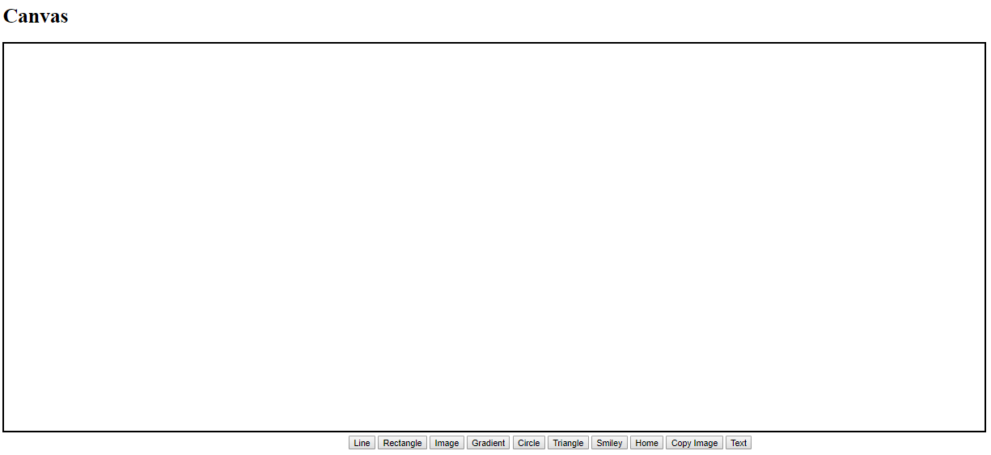

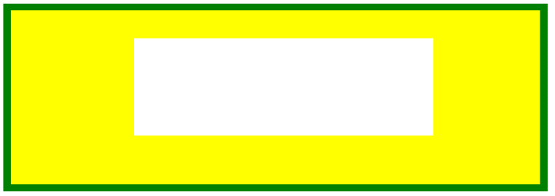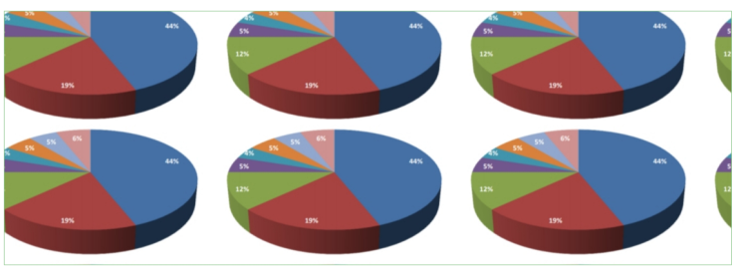

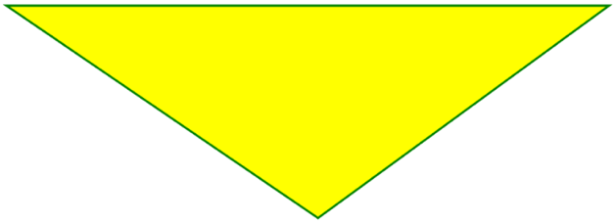

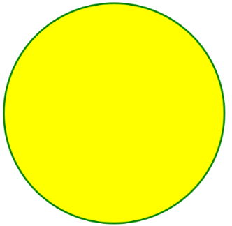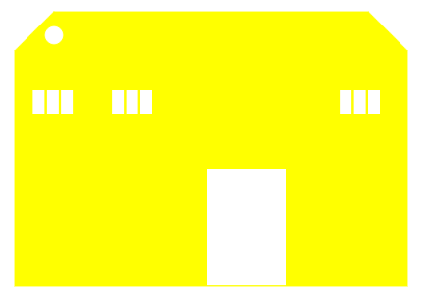

**CONCLUSION:**

In this practical we learn how to use HTML CANVAS and their functionality.

**PART – 3 ( CSS 2.0 )**

**PRACTICAL - 1**

**AIM:** Implement following properties of CSS 2.0.

1. **Background, Font and Text**

**PROGRAM:**

<!DOCTYPE html>

<html>

<head>

<title>Back ground</title>

<style type="text/css">

body{

background-color:lightblue;

background-image:url('download.png');

background-repeat:no-repeat;

background-position:1 1 ;

background-attachment:fixed;

}

</style>

</head>

</html>

**OUTPUT :**



**PROGRAM:**

</html>

<!DOCTYPE html>

<html>

<head>

<title>CSS-Font-Examples</title>

</head>

<style type="text/css">

.border

{

border: 2px solid blue;

}

</style>

<body>

<p class="border" style="font-family: times new roman; font-style: italic; font-size: 24px ; font-weight: bold">

Hello world</p>

</body>

</html>

**OUTPUT:**



**PROGRAM:**

<!DOCTYPE html>

<html>

<head>

<title>CSS-TEXT</title>

<style type="text/css">

p{

font-size:20px;

}

.align {

text-align: right;

}

.decoration {

text-decoration: overline;

}

.decoration-1 {

text-decoration: line-through;

}

.decoration-2

{

text-decoration: underline;

}

.transform

{

text-transform: uppercase;

}

.transform-1{

text-transform: lowercase;

}

.indent {

text-indent: 100px

}

.letter {

letter-spacing: 5px

}

.line {

line-height: 0.8

}

</style>

</head>

<body>

<p class="align"> Use of align property</p>

<p class="decoration">hello</p>

<p class="decoration-1"> hello</p>

<p class="decoration-2">hello</p>

<p class="transform"> hello</p>

<p class="transform-1">hello</p>

<p class="indent"> hello</p>

<p class="letter">hello </p>

<p class="line"> hello </p>

</body>

</html>

**OUTPUT:**

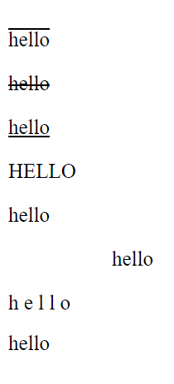

**2.Margin, Padding and Border (Box Model)**

<!DOCTYPE html>

<html>

<head>

<title>CSS-BOX MODEL</title>

<style type="text/css">

.margin

{

margin: 50px;

border: 2px solid green ;

width: 50%;

}

.margin-2

{

margin: 50px 50px;

border: 2px dashed red ;

}

.margin-3

{

margin: 50px 40px 70px;

border: 2px dotted blue ;

}

.margin-4

{

margin: 50px 20px 70px 10px;

border-style: solid dotted dashed double ;

}

.padding

{

padding: 50px;

border: 5px groove green ;

width: 70%;

}

.padding-2

{

padding: 50px 50px;

border: 2px inset red ;

}

.padding-3

{

padding: 50px 40px 70px;

border: 2px outset blue ;

}

.padding-4

{

padding: 50px 20px 70px 10px;

border-style: solid dotted dashed double ;

}

</style>

</head>

<body>

<p align="center">Use of Margin </p>

<p class="margin"> hello </p>

<p class="margin-2"> hello </p>

<p class="margin-3"> hello </p>

<p class="margin-4"> hello </p>

<p>----------------------------------------------------------------------------------------------------------------------------------------------------------------------------------------------------------------------------------------------------------</p>

<p align="center">Use of Padding</p>

<p class="padding"> hello</p>

<p class="padding-2"> hello</p>

<p class="padding-3"> hello </p>

<p class="padding-4"> hello </p>

</body>

</html>

**OUTPUT:**

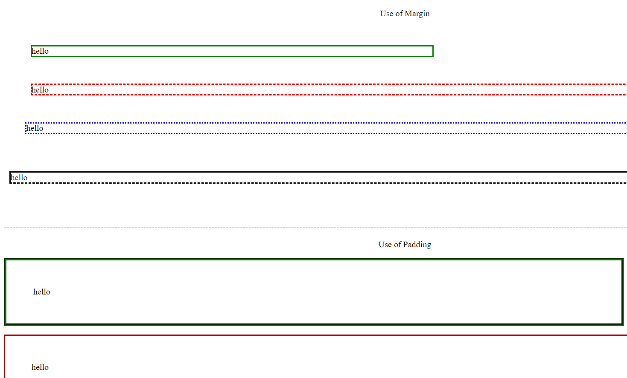

**3.TABLE:**

<!DOCTYPE html>

<html>

<head>

    <title>CSS-TABLE-EXAMPLES</title>

</head>

<body>

<table align="center" border="2" width="50%">

<caption>Use of height width text-align vertical-align</caption>

<tr>

    <th style="height: 50px">1 </th>

    <th>2</th>

    <th>3</th>

    <th>4</th>

</tr>

<tr>

    <td style="text-align: center;">5</td>

    <td>6</td>

    <td>7</td>

    <td style="text-align: right;">8</td>

</tr>

<tr>

    <td style="vertical-align: top; height: 30px">9</td>

    <td style="vertical-align: bottom;">10</td>

    <td style="vertical-align: middle;">11</td>

    <td>12</td>

</tr>

<tr>

    <td>13</td>

    <td>14</td>

    <td>15</td>

    <td>16</td>

</tr>

</table>

<table border="2" style="border-collapse: collapse; margin: 50px; width: 50%;">

    <caption> Use of padding margin border-collapse</caption>

<tr>

    <th style="padding: 20px">1 </th>

    <th>2</th>

    <th>3</th>

    <th>4</th>

</tr>

<tr>

    <td style="text-align: center;padding: 20px">5</td>

    <td>6</td>

    <td>7</td>

    <td style="text-align: right;">8</td>

</tr>

<tr>

    <td>9</td>

    <td>10</td>

    <td>11</td>

    <td>12</td>

</tr>

<tr>

    <td>13</td>

    <td>14</td>

    <td>15</td>

    <td>16</td>

</tr>

</table>

</body>

</html>

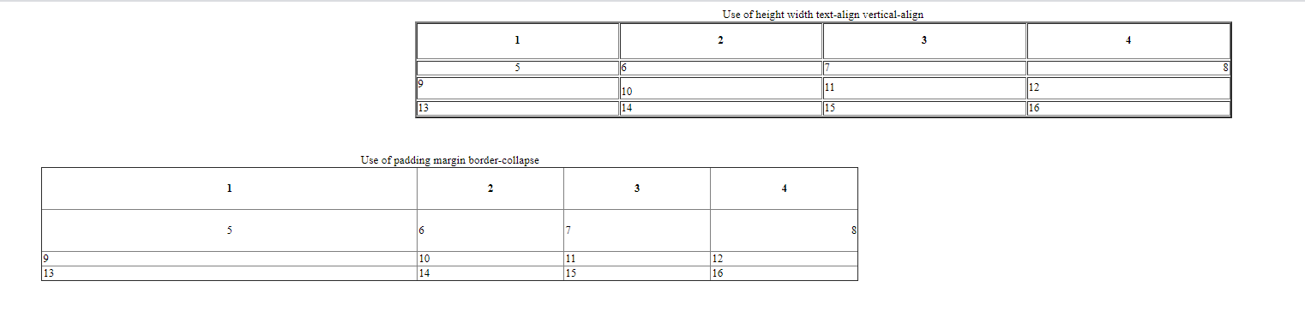**OUTPUT:**

**4.DISPLAY:**

**PROGRAM:**

<!DOCTYPE html>

<html>

<head>

<title>CSS-DISPLAY-EXAMPLES</title>

<style type="text/css">

p.h{display: inline-block;

border: 2px solid darkviolet;

}

img{display: block;}

</style>

</head>

<body>

<p class="h" style="color: white; background-color: orange "> This is the use of display</p>

<p class="h" style="color: blue; background-color: white"> Here P tag is block level text</p>

<p class="h" style="color: white;background-color: green"> converting to inline</p>

<br>

<p>-----------------------------------------------------------------------------------------------------------------------------------------------------------</p>

<br>

<img src="demo.png" alt="image1"/>

<img src="demoimage.png" alt="image2"/>

<img src="demo.png" alt="image3"/>

</body>

</html>

**OUTPUT:**

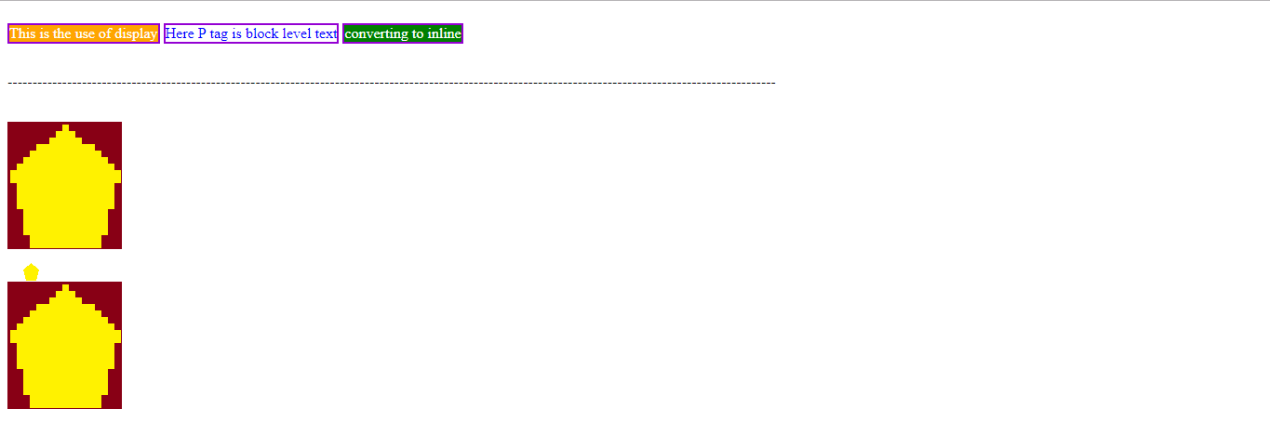

**5. POSITION**

**PROGRAM:**

<!DOCTYPE html>

<html><!DOCTYPE html>

<html>

<head>

<style>

h2 {

position: absolute;

left: 100px;

top: 150px;

}

</style>

</head>

<body>

<h1>The position Property</h1>

<h2>This is a heading with an absolute position</h2>

<p>With absolute positioning, an element can be placed anywhere on a page. The heading below is placed 100px from the left of the page and 150px from the top of the page.</p>

</body>

</html>

**OUTPUT:**

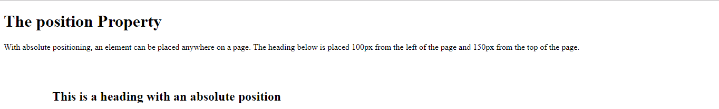

**6.FLOATING**

**PROGRAM:**

<!DOCTYPE html>

<html>

<head>

<title>CSS-FLOAT-CLEAR-EXAMPLES</title>

</head>

<body>

<p style="border: 2px solid green; overflow: auto">

<img src="demo.png" style="float: right;">This is the use of float.

<p>---------------------------------------------------------------------------------------------------------------------------------------------------------</p>

<div style="border: 2px solid red; float :left">This is the use of float <img src="demo.png"></div>

</body>

</html>

**OUTPUT :**

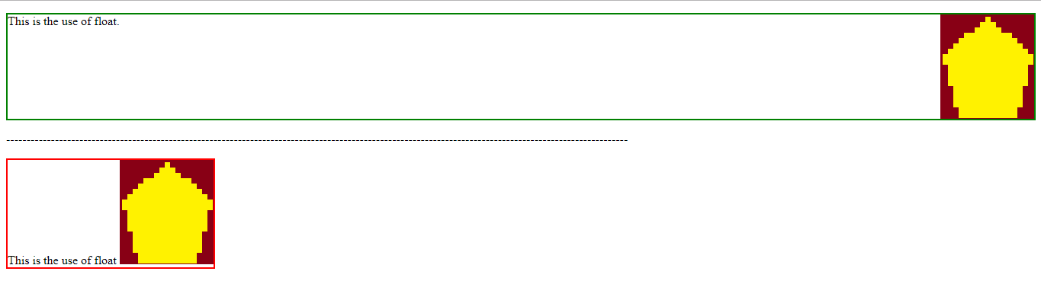

**7. PSUEDO ELEMENTS**

**PROGRAM :**

<!DOCTYPE html>

<html>

<head>

<link rel="icon" type="image/x-icon" href="dep.png"/>

<title>My Website</title>

<style type="text/css">

a:link

{

color:green;

}

a:visited

{

color:red;

}

a:hover

{

color:yellow;

}

a:active

{

color:black;

}

</style>

</head>

<body>

<a href="https://www.google.com" >link1</a><br>

<a href="https://www.google.com" >link2</a><br>

<a href="https://www.google.com" >link3</a><br>

<a href="https://www.google.com" >link4</a><br>

</body>

</html>

**OUTPUT :**

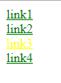

**CONCLUSION:**

In this practical we learn how to Implement properties of CSS 2.0 and their effect.

**PRACTICAL - 2**

**AIM:** Create Cascading menu using CSS2.0.

**PROGRAM:**

<!DOCTYPE html>

<html>

<head>

<title>Menu</title>

<style type="text/css">

a{

text-decoration:none;

}

.nav1{

position:relative;

left:100px;

width:1110px;

}

.b1{

position:absolute;

size:12px;

background-color:gray;

border:3px inset blue;

display:none;

height:120px;

width:810px;

left:0px;

}

.c1:hover .b1{

display:inline-block;

}

.home:hover{

background-color:red;

}

.b2{

position:absolute;

size:12px;

background-color:gray;

border:3px inset blue;

display:none;

height:220px;

width:810px;

left:0px;

}

.c2:hover .b2{

display:inline-block;

}

.about:hover{

background-color:yellow;

}

.b3{

position:absolute;

size:12px;

background-color:gray;

border:3px inset blue;

display:none;

height:220px;

width:810px;

left:0px;

}

.c3:hover .b3{

display:inline-block;

}

.glance{

display:none;

}

.contect:hover{

background-color:blue;

}

</style>

</head>

<body>

<div style="vertical-align:top" style="background-color:lightblue;">

<img src='download.png' alt='image is not avaliable' style="width:300px; height:100px;float:left;" />

<br>

<h3 align="center" style="font-size:30px;margin-top:20px;">Charotar University of Science and Technology</h3>

<hr>

</div>

<div class="nav1">

<div class="c1" style="float:left">

<button class="home">DEPSTAR</button>

<div class="b1" style="height:220px;">

<img src="dep.png" alt="DEPSTAR" height=100px width=100px style="float: left;margin-top:12px; margin-left:10px;">

<p style="margin-left: 130px">Devang Patel Institute of Advance Technology and Research- (DEPSTAR) Changa is the eighth institute, established under education campus of CHARUSAT. The institute is managed through a think tank of technocrats, administrators, scientists and engineers, educationalist, businessmen, stakeholders and other well-wishers from all parts of the world. The institute now has total intake of 300 in Computer Engineering, Information Technology and Computer Science and Engineering.</p>

<div>

<div style="float:left;vertical-align: top;margin-top:-15px; ">

<ul>

<li><a href="https://www.charusat.ac.in/DPIATR/" target="_blanks">DEPSTAR</a></li>

<li><a href="https://www.charusat.ac.in/DPIATR/workshops-and-seminars/" target="_blanks">WORKSHOP & SEMINARS</a></li>

<li><a href="https://www.charusat.ac.in/DPIATR/expert-talks/" target="_blanks">EXPERT TALKS</a></li>

<li><a href="https://www.charusat.ac.in/DPIATR/syllabus-5/" target="_blanks">SYLLABUS</a></li>

<li><a href="https://www.charusat.ac.in/DPIATR/innovation-clubs/" target="_blanks">STUDENT CLUB</a></li>

</ul>

</div>

<div>

<ul style="margin-left:300px;">

<li><a href="https://www.charusat.ac.in/DPIATR/computer-science-and-engineering/" target="_blanks">CSE</a></li>

<li><a href="https://www.charusat.ac.in/DPIATR/computer-engineering-2/" target="_blanks">CE</a></li>

<li><a href="https://www.charusat.ac.in/DPIATR/information-technology-2/" target="_blanks">IT</a></li>

<li><a href="https://www.charusat.ac.in/DPIATR/" target="_blanks">ABOUT US</a></li>

</ul>

</div>

</div>

</div>

</div>

<div class="c2" style="float:left">

<button class="about">CSPIT</button>

<div class="b2">

<img src="cspit.png" alt="CSPIT" height=100px width=100px style="float: left;margin-top:12px; margin-left:10px;">

<p style="margin-left: 130px">Devang Patel Institute of Advance Technology and Research- (DEPSTAR) Changa is the eighth institute, established under education campus of CHARUSAT. The institute is managed through a think tank of technocrats, administrators, scientists and engineers, educationalist, businessmen, stakeholders and other well-wishers from all parts of the world. The institute now has total intake of 300 in Computer Engineering, Information Technology and Computer Science and Engineering.</p>

<div>

<div style="float:left;vertical-align: top;margin-top:-15px; ">

<ul>

<li><a href="https://www.charusat.ac.in/DPIATR/" target="_blanks">DEPSTAR</a></li>

<li><a href="https://www.charusat.ac.in/DPIATR/workshops-and-seminars/" target="_blanks">WORKSHOP & SEMINARS</a></li>

<li><a href="https://www.charusat.ac.in/DPIATR/expert-talks/" target="_blanks">EXPERT TALKS</a></li>

<li><a href="https://www.charusat.ac.in/DPIATR/syllabus-5/" target="_blanks">SYLLABUS</a></li>

<li><a href="https://www.charusat.ac.in/DPIATR/innovation-clubs/" target="_blanks">STUDENT CLUB</a></li>

</ul>

</div>

<div>

<ul style="margin-left:300px;">

<li><a href="https://www.charusat.ac.in/DPIATR/computer-science-and-engineering/" target="_blanks">CSE</a></li>

<li><a href="https://www.charusat.ac.in/DPIATR/computer-engineering-2/" target="_blanks">CE</a></li>

<li><a href="https://www.charusat.ac.in/DPIATR/information-technology-2/" target="_blanks">IT</a></li>

<li><a href="https://www.charusat.ac.in/DPIATR/" target="_blanks">ABOUT US</a></li>

</ul>

</div>

</div>

</div>

</div>

<div class="c3" style="float:left;">

<button class="contect">RPCP</button>

<div class="b3">

<img src="rpcp.png" alt="RPCP" height=100px width=100px style="float: left;margin-top:12px; margin-left:10px;">

<p style="margin-left: 130px">Devang Patel Institute of Advance Technology and Research- (DEPSTAR) Changa is the eighth institute, established under education campus of CHARUSAT. The institute is managed through a think tank of technocrats, administrators, scientists and engineers, educationalist, businessmen, stakeholders and other well-wishers from all parts of the world. The institute now has total intake of 300 in Computer Engineering, Information Technology and Computer Science and Engineering.</p>

<div>

<div style="float:left;vertical-align: top;margin-top:-15px; ">

<ul>

<li><a href="https://www.charusat.ac.in/DPIATR/" target="_blanks">DEPSTAR</a></li>

<li><a href="https://www.charusat.ac.in/DPIATR/workshops-and-seminars/" target="_blanks">WORKSHOP & SEMINARS</a></li>

<li><a href="https://www.charusat.ac.in/DPIATR/expert-talks/" target="_blanks">EXPERT TALKS</a></li>

<li><a href="https://www.charusat.ac.in/DPIATR/syllabus-5/" target="_blanks">SYLLABUS</a></li>

<li><a href="https://www.charusat.ac.in/DPIATR/innovation-clubs/" target="_blanks">STUDENT CLUB</a></li>

</ul>

</div>

<div>

<ul style="margin-left:300px;">

<li><a href="https://www.charusat.ac.in/DPIATR/computer-science-and-engineering/" target="_blanks">CSE</a></li>

<li><a href="https://www.charusat.ac.in/DPIATR/computer-engineering-2/" target="_blanks">CE</a></li>

<li><a href="https://www.charusat.ac.in/DPIATR/information-technology-2/" target="_blanks">IT</a></li>

<li><a href="https://www.charusat.ac.in/DPIATR/" target="_blanks">ABOUT US</a></li>

</ul>

</div>

</div>

</div>

</div>

</div><br>

<hr>

<!-- <div class="glance">

<h3><u>CHARUSAT at a glance</u></h3>

<ul>

<li><p align="justify">Charotar University of Science and Technology (CHARUSAT) has been conceived by Shri Charotar Moti Sattavis Patidar Kelavani Mandal to make Charotar – the Land of Sardar Patel the Global Education Hub. Kelavani Mandal is a premier education trust of India. It has an ancestry of social service of more than 125 years old social organization.</p>

<li><p align="justify">CHARUSAT has been established under Gujarat Private University Act No. 8 of 2009. It is empowered to confer degrees under Section 22 of UGC Act 1956. It is the first State University getting “A” Grade in Gujarat in the first cycle by National Assessment and Accreditation Council, NAAC, Bangalore.</p>

<li><p align="justify">Presently, CHARUSAT offers 72 programs from Undergraduate to Doctoral (Ph D) under the tutelage of 9 Institutes, 6 Faculties, 4 Major Centres / Cells, employee strength of 550, student strength of 7500 and a Capital Outlay of INR 150 Crores. The programs are offered in the allied disciplines of Technology & Engineering, Pharmacy, Computer Applications, Management Studies, Applied Sciences, Nursing, Physiotherapy, and other Paramedical Sciences.</p>

<li><p align="justify">All programs are semester based and are delivered in English Medium. Credit and Grading Systems are followed for Teaching, Learning and Evaluation. Curriculum and Pedagogy correspond with societal needs. Industrial Visits, Study Tours, Interactive IT enabled Teaching Practice, Project / Case / Task Based Learning, Blended Learning, and Expert Lectures form an integral part of innovative pedagogy at CHARUSAT.</p>

<li><p align="justify">The Iron Man of India, Sardar Vallabhbhai Patel believed, “Education without character is futile”. CHARUSAT proudly follows this spirit. It also follows founding High Moral Values like Honesty, Integrity, Transparency, Fairness, Equity, and Accountability. </p>

</ul>

</div> -->

</body>

</html>

OUTPUT :



**CONCLUSION:** In this practical we learn how to made Cascading menu using CSS2.0.

**PRACTICAL - 3**

**AIM:** Create an overlay div with CSS2.0

**PROGRAM:**

<!DOCTYPE html>

<html>

<head>

<link rel="icon" type="image/x-icon" href="dep.png"/>

<title>My Website</title>

<link rel="stylesheet" type="text/css" href="mycss.css">

</head>

<body>

<div>

<a href="#bottom" >Go to bottom</a>

<div style="vertical-align:top" style="background-color:lightblue;">

<p align="center" ><img src='download.png' alt='image is not avaliable' style="width:300px; height:150px" />

<h3 align="center" style="font-size:25px;">Charotar University of Science and Technology</h3></p>

<hr>

</div>

<div>

<h3><u>About us</u></h3>

<ul><li><p align="justify">Charotar University of Science and Technology is established under the Gujarat Act No. 8 of 2009, Government of Gujarat. University Grants Commission has empowered CHARUSAT to award Degrees under Section 22 of UGC Act 1956. </p></ul>

</div>

<div>

<h3><u>CHARUSAT at a glance</u></h3>

<ul>

<li><p align="justify">Charotar University of Science and Technology (CHARUSAT) has been conceived by Shri Charotar Moti Sattavis Patidar Kelavani Mandal to make Charotar – the Land of Sardar Patel the Global Education Hub. Kelavani Mandal is a premier education trust of India. It has an ancestry of social service of more than 125 years old social organization.</p>

<li><p align="justify">CHARUSAT has been established under Gujarat Private University Act No. 8 of 2009. It is empowered to confer degrees under Section 22 of UGC Act 1956. It is the first State University getting “A” Grade in Gujarat in the first cycle by National Assessment and Accreditation Council, NAAC, Bangalore.</p>

<li><p align="justify">Presently, CHARUSAT offers 72 programs from Undergraduate to Doctoral (Ph D) under the tutelage of 9 Institutes, 6 Faculties, 4 Major Centres / Cells, employee strength of 550, student strength of 7500 and a Capital Outlay of INR 150 Crores. The programs are offered in the allied disciplines of Technology & Engineering, Pharmacy, Computer Applications, Management Studies, Applied Sciences, Nursing, Physiotherapy, and other Paramedical Sciences.</p>

<li><p align="justify">All programs are semester based and are delivered in English Medium. Credit and Grading Systems are followed for Teaching, Learning and Evaluation. Curriculum and Pedagogy correspond with societal needs. Industrial Visits, Study Tours, Interactive IT enabled Teaching Practice, Project / Case / Task Based Learning, Blended Learning, and Expert Lectures form an integral part of innovative pedagogy at CHARUSAT.</p>

<li><p align="justify">The Iron Man of India, Sardar Vallabhbhai Patel believed, “Education without character is futile”. CHARUSAT proudly follows this spirit. It also follows founding High Moral Values like Honesty, Integrity, Transparency, Fairness, Equity, and Accountability. </p>

</ul>

</div>

<div style="vertical-align:top float:right">

<div style="float:left">

<h3>Quick Links

<ul>

<li><a href="https://www.charusat.ac.in/CSPIT/" style="font-size:15px;">CSPIT</a><br>

<li><a href="https://www.charusat.ac.in/DPIATR/" style="font-size:15px;">DEPSTAR</a><br>

<li><a href="https://www.charusat.ac.in/RPCP/" style="font-size:15px;">RPCP</a><br>

<li><a href="https://www.charusat.ac.in/CMPICA/" style="font-size:15px;">CMPICA</a><br>

<li><a href="https://www.charusat.ac.in/PDPIAS/" style="font-size:15px;">PDPIAS</a><br></h3>

<a href="#top" name="bottom" >Back to top</a><br>

<a href="form.html" name="bottom" > Registration form</a>

<!-- <iframe src="index.html" width="1300px" align="center" height="250px">

<p>Your browser does not support iframes.</p>

</iframe> -->

</ul>

</div>

<div style="float:right;margin:50px 30px 0 0">

<a href="https://www.charusat.ac.in/CSPIT/" /><img src='cspit.png' alt='image is not avaliable' style="width:180px; height:150px" />

<a href="https://www.charusat.ac.in/DPIATR/" /><img src='dep.png' alt='image is not avaliable' style="width:180px0px; height:150px" />

<a href="https://www.charusat.ac.in/RPCP/" /><img src='rpcp.png' alt='image is not avaliable' style="width:180px0px; height:150px" />

<a href="https://www.charusat.ac.in/CMPICA/" /><img src='cm.jpg' alt='image is not avaliable' style="width:180pxpx; height:150px" />

<a href="https://www.charusat.ac.in/PDPIAS/" /><img src='pd.png' alt='image is not avaliable' style="width:180px; height:150px" />

<!-- <a href="https://www.charusat.ac.in/PDPIAS/" /><img src='200w_s.gif' alt='image is not avaliable' style="width:180px; height:150px" /> -->

</div>

</div>

</div>

</body>

</html>

OUTPUT :



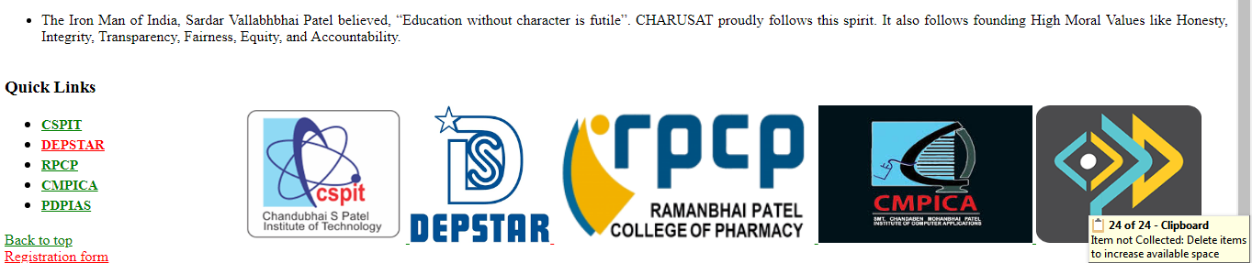

**CONCLUSION:**

In this practical we implement CSS properties in our web page.

**PART-4 ( CSS 3.0 )**

**PRACTICAL-1**

**AIM:** To implement background and border properties using CSS3.0

**PROGRAM:**

<!DOCTYPE html>

<html>

<head>

<title>Boder and Background</title>

<style type="text/css">

html{

background-color: cyan;

}

body{

display: inline-grid;

}

.div1{

margin:10px;

float: left;

padding: 5px;

width: 130px;

height: 130px;

border-width: 3px;

border-style: solid;

border-radius: 20px;

}

.div2{

margin:10px;

float: left;

padding: 5px;

width: 130px;

height: 130px;

border-width: 2px;

border-style: dotted;

border-radius: 10px;

}

.div3{

margin:10px;

padding: 5px;

width: auto;

height: auto;

border:solid 2px gold;

border-right-color: red;

border-left-color: blue;

border-top-color:yellow;

border-bottom-color: black;

border-left-width: 4px;

border-top-width: 12px;

border-right-width: 20px;

border-bottom-width: 30px;

background-color: white

}

</style>

</head>

<body>

<div style="display: inline;float: left;">

<div class="div1">

<p>border-width: 3px;

border-style: solid;

border-radius: 20px;</p>

</div>

<div class="div2">

<p>border-width: 2px;

border-style: dotted;

border-radius: 10px;</p>

</div>

</div>

<div class="div3">

<p>

border:solid 2px gold;<br>

border-right-color: red;<br>

border-left-color: blue;<br>

border-top-color:yellow; <br>

border-bottom-color: black;<br>

border-left-width: 4px;<br>

border-top-width: 8px;<br>

border-right-width: 12px;<br>

border-bottom-width: 16px;<br>

background-color: white

</p>

</div>

</body>

</html>

**OUTPUT:**

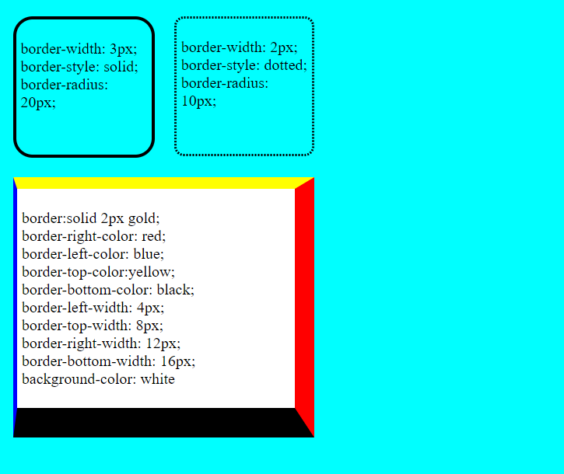

**CONCLUSION:**

We implemented background and border properties using CSS3.0

**PRACTICAL-2**

**AIM:** Implement Text effects properties using CSS3.0

**PROGRAM:**

<html>

<head>

<style>

p.test1 {

white-space: nowrap;

width: 200px;

border: 1px solid #000000;

overflow: hidden;

text-overflow: clip;

}

p.test2 {

white-space: nowrap;

width: 200px;

border: 1px solid #000000;

overflow: hidden;

text-overflow: ellipsis;

}

p.test3 {

width: 140px;

border: 1px solid #000000;

word-break: keep-all;

}

p.test4 {

width: 140px;

border: 1px solid #000000;

word-break: break-all;

}

</style>

</head>

<body>

<h2>text-overflow: clip:</h2>

<p class="test1">This is some long text that will not fit in the box</p>

<h2>text-overflow: ellipsis:</h2>

<p class="test2">This is some long text that will not fit in the box</p>

<h2>word-break: keep-all :</h2>

<p class="test3">This paragraph contains some text. This line will-break-at-hyphens.</p>

<h2>word-break: break-all</h2>

<p class="test4">This paragraph contains some text. The lines will break at any character.</p>

</body>

</html>

OUTPUT:

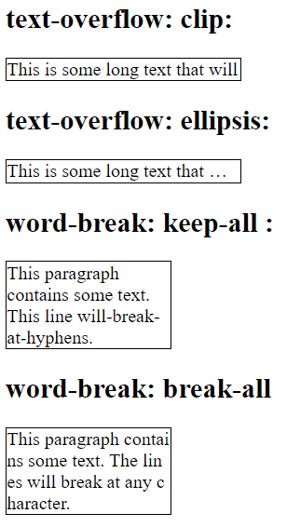

**CONCLUSION:**

We Implemented Text effects properties using CSS3.

**PRACTICAL-3**

**AIM:** Implement 2D and 3D Transform properties using CSS3.0

**PROGRAM:**

<!DOCTYPE html>

<html>

<head>

<title>Transition</title>

<style type="text/css">

.t1{

width: 70px;

height: 70px;

background-color: red;

}

.t1:hover{

width: 150px;

height: 150px;

background-color: red;

transform: rotateZ(135deg);

}

#t2

{

background-color: blue;

text-align: center;

width: 100px;

height: 100px;

border-radius: 200px 200px 200px 200px;

border: 1px;

transition: transform 3s,background-color 2s,font 2s,margin 2s;

}

#t2:hover

{

background-color: orange;

margin: 50px 0px 20px 50px;

font:20px;

transform: rotateZ(90deg) scale(2,2);

transition-timing-function: ease-in-out;

}

</style>

</head>

<body>

<div class="t1">

<p>2d transition</p>

</div>

<div id="t2">

</div>

</body>

</html>

**OUTPUT:**

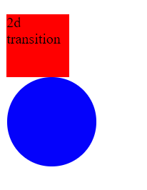

**CONCLUSION:**

We implemented 2D and 3D Transform properties using CSS3.0

**PRACTICAL-4**

**AIM:** Implement Animation properties using CSS3.0

**PROGRAM:**

<!DOCTYPE html>

<html>

<head>

<style>

div {

width: 100px;

height: 100px;

background-color: red;

position: relative;

animation-name: anim;

animation-duration: 6s;

}

@keyframes anim {

0% {background-color:red; left:0px; top:0px;}

25% {background-color:blue; left:200px; top:0px;}

50% {background-color:yellow; left:200px; top:200px;}

75% {background-color:purple; left:0px; top:200px;}

100% {background-color:red; left:0px; top:0px;}

}

</style>

</head>

<body>

<div></div>

</body>

</html>

**OUTPUT:**



**CONCLUSION:**

We implement Animation properties using CSS3.0

**PRACTICAL-5**

**AIM:** Implement Column Layout properties using CSS3.0

**PROGRAM:**

<!DOCTYPE html>

<html>

<head>

<style>

*{

box-sizing: border-box;

}

.column {

float: left;

width: 30%;

padding: 10px;

height: 300px;

}

.row:after {

content: "";

display: table;

clear: both;

}

</style>

</head>

<body>

<div class="row">

<div class="column" style="background-color:red;">

<h2>Column 1</h2>

</div>

<div class="column" style="background-color:yellow;">

<h2>Column 2</h2>

</div>

<div class="column" style="background-color:cyan;">

<h2>Column 3</h2>

</div>

</div>

</body>

</html>

**OUTPUT:**

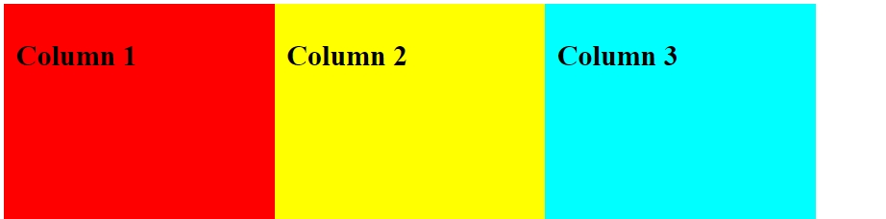

**CONCLUSION:**

We implement Column Layout properties using CSS3.

**PRACTICAL-6**

**AIM:** Implementation User Interface properties using CSS3.0

**PROGRAM:**

<!DOCTYPE html>

<html>

<head>

<style>

div {

border: 2px solid;

padding: 20px;

width: 300px;

resize: both;

overflow: auto;

margin: 10px;

border: 1px solid black;

outline: 5px dashed red;

outline-offset: 5px;

}

</style>

</head>

<body>

<div>

<p>Resize the box using corner arrow</p>

</div>

</body>

</html>

**OUTPUT:**

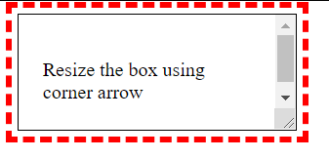

**CONCLUSION:**

We implemented User Interface properties using CSS3.0

**PART–5 ( JAVA SCRIPTS & DOM )**

**PRACTICAL - 1**

**AIM:** Create JavaScript function for basic arithmetic operations (Addition,Subtraction, Multiplication and Division). Create proper design layout which asks two numbers to enter from user and display result of respective operation on clicking respective button.

**PROGRAM:**

<!DOCTYPE html>

<html>

<head>

<title>

JAVA SCRIPT

</title>

</head>

<body>

<script type="text/javascript">

var a=parseInt(prompt("Enter the value of a :"));

var b=parseInt(prompt("Enter the value of b :"));

/*var a=document.getElementById("num1").value;

var b=document.getElementById("num2").value;*/

function add(){

var c=a+b;

document.write("Addition of "+a+" and "+b+" is "+c+"<br>");

}

function sub(){

c=a-b;

document.write("Subtraction of "+a+" and "+b+" is "+c+"<br>");

}

function mul(){

c=a*b;

document.write("Multiplication of "+a+" and "+b+" is "+c+"<br>");

}

function div(){

c=a/b;

document.write("Division of "+a+" and "+b+" is "+c+"<br>");

}

</script>

<div>

<!-- <div>

<label>Number1 : </label><input type="text" id="num1"><br><br>

</div>

<div>

<label>Number2 : </label><input type="text" id="num2"><br><br>

</div> -->

<div>

<button onclick="add()">Addition</button>

<button onclick="sub()">Subtraction</button>

<button onclick="mul()">Multiplication</button>

<button onclick="div()">Division</button>

</div>

</div>

</body>

</html>

**OUTPUT:**

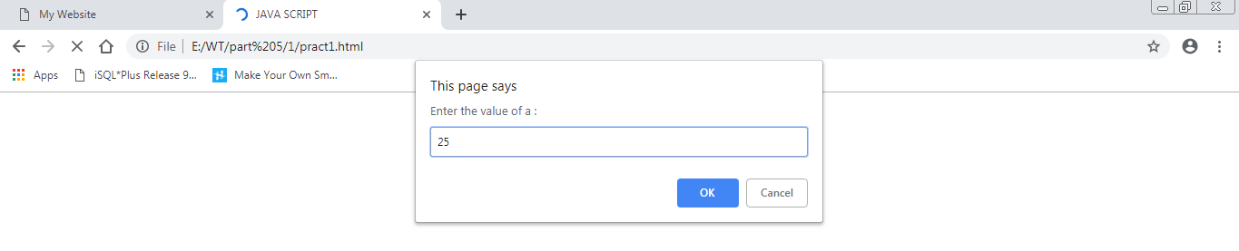

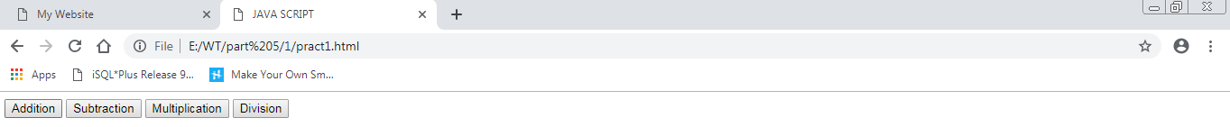





**CONCLUSION:**

In this practical we made basic calculator using JavaScript basic function.

**PRACTICAL - 2**

**AIM:** Create HTML form like any registration form with all necessary controls. Write a JavaScript which retrieve all possible value from controls and display on webpage. Use some style rules to format

**PROGRAM:**

<!doctype html>

<html>

<head>

<title>My Table</title>

<script type="text/javascript">

function display() {

var a=document.getElementById("firstname").value;

var b=document.getElementById("lastname").value;

var c=document.getElementById("uid").value;

var d=document.getElementById("password").value;

var e=document.getElementById("add").value;

if(document.getElementById("radio1").checked)

{

var f=document.getElementById("radio1").value;

}

else

{

var f=document.getElementById("radio2").value;

}

var g=document.getElementById("check1").value;

var h=document.getElementById("check2").value;

var i=document.getElementById("check3").value;

var j="";

if(g!=" ")

j=g+" ";

if(h!=" ")

j=j+h+" ";

if(g!=" ")

i=j+i+" ";

document.write("First name : "+a);

document.write("<br>");

document.write("Last name : "+b);

document.write("<br>");

document.write("User Id : "+c);

document.write("<br>");

document.write("Password : "+d);

document.write("<br>");

document.write("Address : "+e);

document.write("<br>");

document.write("Gender : "+f);

document.write("<br>");

document.write("Hobby : "+h);

return true;

}

</script>

</head>

<body>

<div>

<table>

<form>

<div>

<h1>Form</h1>

</div>

<div>

<p>First Name : <input type="text" name="firstname" id="firstname" placeholder="Enter the first name"/></p>

</div>

<div>

<p>Last Name : <input type="text" name="lastname" id="lastname" placeholder="Enter the last name" /></p>

</div>

<div>

<p>User ID : <input type="text" name="uid" id="uid" placeholder="Enter the User ID" /></p>

</div>

<div>

<p>Password : <input type="password" name="password" id="password" placeholder="Enter the password" /></p>

</div>

<div>

<p>Gender : <input type="radio" name="radio1" id="radio1" value="male" checked />Male<input type="radio" name="radio1" id="radio2" value="female" />Female</p>

</div>

<div>

<p>Hobby : <input type="checkbox" name="check1" id="check1" value="swiming" />Swiming<input type="checkbox" name="check1" id="check2" value="reading" />Reading<input type="checkbox" id="check3" name="check1" value="writing" />writing</p>

</div>

<div>

<p>Address : <textarea row=6 column=50 id="add" placeholder="Enter the Address"></textarea></p>

</div>

<div>

<input type="button" name="Submit" value="Submit" onclick="return display()">

</div>

</form>

</table>

</div>

</body>

</html>

**OUTPUT:**

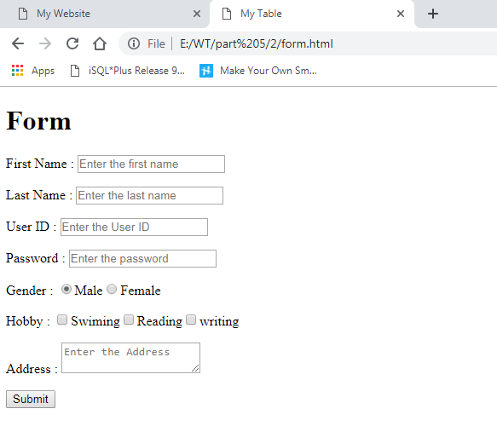

**CONCLUSION:**

In this practical we learn how to retrieve data from form using JavaScript.

**PRACTICAL - 3**

**AIM:** Create JavaScript for form Validation for following tasks

a. Text box must have required value.

b. Textbox must accept only letters.

c. Textbox must accept only numbers.

d. Textbox must contain character in the range of 6-12.

e. Compare entered password and confirmed password.

f. Check whether radio button, check box or dropdown box

has selected or not.

g. Email validation.

h. Mobile number validation.

Design proper HTML form and perform all above task.

**PROGRAM:**

<!DOCTYPE html>

<html>

<head>

<title>Form validation</title>

<script>

function check()

{

var name = document.forms["RegForm"]["Name"];

var email = document.forms["RegForm"]["EMail"];

var phone = document.forms["RegForm"]["Telephone"];

var what = document.forms["RegForm"]["Subject"];

var password = document.forms["RegForm"]["Password"];

var cpassword = document.forms["RegForm"]["Confirm_Password"];

var address = document.forms["RegForm"]["Address"];

var regex = /^[a-zA-Z]+$/;

var reg = /^([0-9]{10})+$/;

var ck_password = /^([a-zA-Z0-9]{6,12})+$/;

if (name.value == "")

{

window.alert("Please enter your name.");

name.focus();

return false;

}

if(regex.test(name.value) == false){

alert("Name must be in letters only");

name.focus();

return false;

}

if (address.value == "")

{

window.alert("Please enter your address.");

name.focus();

return false;

}

if (email.value == "")

{

window.alert("Please enter a valid e-mail address.");

email.focus();

return false;

}

if (email.value.indexOf("@", 0) < 0)

{

window.alert("Please enter a valid e-mail address.");

email.focus();

return false;

}

if (email.value.indexOf(".", 0) < 0)

{

window.alert("Please enter a valid e-mail address.");

email.focus();

return false;

}

if (password.value == "")

{

window.alert("Please enter your password");

password.focus();

return false;

}

if (ck_password.test(password.value) == false) {

window.alert("You must enter a valid Password ");

password.focus();

return false;

}

if (cpassword.value == "")

{

window.alert("Please enter your confirm password");

password.focus();

return false;

}

if ((cpassword.value)!=(password.value)) {

window.alert("Enter Password and Confirm Password same");

cpassword.focus();

return false;

}

if (phone.value == "")

{

window.alert("Please enter your telephone number.");

phone.focus();

return false;

}

if(reg.test(phone.value) == false){

alert("Name must be in numbers only in 10 digits");

phone.focus();

return false;

}

if (what.selectedIndex < 1)

{

alert("Please enter your course.");

what.focus();

return false;

}

alert("welcome,your registration confirm.");

return true;

}</script>

</head>

<body>

<h1 style="text-align: center"> REGISTRATION FORM </h1>

<form name="RegForm" onsubmit="return check()" method="post">

<p>Name: <input type="text" name="Name"></p>

<p> Address: <input type="text" name="Address"></p>

<p>E-mail Address: <input type="text" name="EMail"></p>

<p>Password: <input type="password" name="Password"></p>

<p>Confirm Password: <input type="password" name="Confirm_Password"></p>

<p>Telephone: <input type="text" name="Telephone"></p>

<p>Select your course

<select type="text" value="" name="Subject">

<option>Select your course</option>

<option>BBA</option>

<option>BCA</option>

<option>B.COM</option>

<option>M.Tech</option>

</select></p>

<p><input type="submit" value="submit" name="Submit">

</p>

</form>

</body>

</html>

**OUTPUT:**

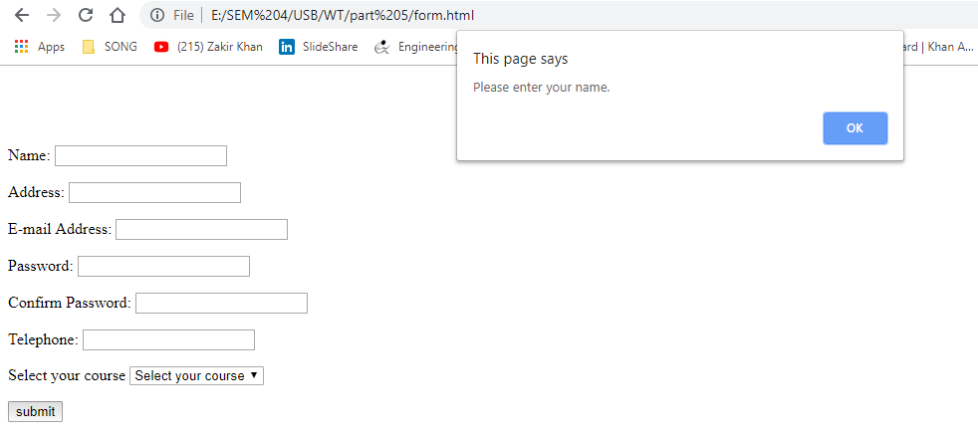

**CONCLUSION:**

In this practical we learn how to validate form using JavaScript.

**PRACTICAL-4**

**AIM:** Create Dynamic table using DOM which perform following tasks:

* Add new Row and Cell
* Delete Row and Cell.

**PROGRAM:**

<!DOCTYPE html>

<html>

<head>

<title>Dynamically Add Remove Table Rows in JavaScript</title>

<style>

table

{

width: 70%;

font: 17px Calibri;

}

table, th, td

{

border: solid 1px #DDD;

border-collapse: collapse;

padding: 2px 3px;

text-align: center;

}

</style>

</head>

<body onload="createTable()">

<ps>Click the "Add New Row" button to add row to the table. Enter values in each row and press the "Submit Data" button. You can check the result in your browsers console window.</p>

<p>

<input type="button" id="addRow" value="Add New Row" onclick="addRow()" />

</p>

<!--THE CONTAINER WHERE WE'll ADD THE DYNAMIC TABLE-->

<div id="cont"></div>

<p><input type="button" id="bt" value="Sumbit Data" onclick="sumbit()" /></p>

</body>

<script>

// ARRAY FOR HEADER.

var arrHead = new Array();

arrHead = ['', 'Emp. Name', 'Designation', 'Age'];

function createTable() {

var empTable = document.createElement('table');

empTable.setAttribute('id', 'empTable'); // SET THE TABLE ID.

var tr = empTable.insertRow(-1);

for (var h = 0; h <arrHead.length; h++) {

var th = document.createElement('th'); // TABLE HEADER.

th.innerHTML = arrHead[h];

tr.appendChild(th);

}

var div = document.getElementById('cont');

div.appendChild(empTable); // ADD THE TABLE TO YOUR WEB PAGE.

}

// ADD A NEW ROW TO THE TABLE.s

function addRow() {

var empTab = document.getElementById('empTable');

var rowCnt = empTab.rows.length; // GET TABLE ROW COUNT.

var tr = empTab.insertRow(rowCnt); // TABLE ROW.

tr = empTab.insertRow(rowCnt);

for (var c = 0; c <arrHead.length; c++) {

var td = document.createElement('td'); // TABLE DEFINITION.

td = tr.insertCell(c);

if (c == 0) { // FIRST COLUMN.

// ADD A BUTTON.

var button = document.createElement('input');

// SET INPUT ATTRIBUTE.

button.setAttribute('type', 'button');

button.setAttribute('value', 'Remove');

// ADD THE BUTTON's 'onclick' EVENT.

button.setAttribute('onclick', 'removeRow(this)');

td.appendChild(button);

}

else {

// CREATE AND ADD TEXTBOX IN EACH CELL.

var ele = document.createElement('input');

ele.setAttribute('type', 'text');

ele.setAttribute('value', '');

td.appendChild(ele);

}

}

}

// DELETE

function removeRow(oButton) {

var empTab = document.getElementById('empTable');

empTab.deleteRow(oButton.parentNode.parentNode.rowIndex);

}

function sumbit() {

var myTab = document.getElementById('empTable');

var values = new Array();

for (row = 1; row <myTab.rows.length - 1; row++) {

for (c = 0; c <myTab.rows[row].cells.length; c++) {

var element = myTab.rows.item(row).cells[c];

if (element.childNodes[0].getAttribute('type') == 'text') {

values.push("'" + element.childNodes[0].value + "'");

}

}

}

console.log(values);

}

</script>

</html>

**OUTPUT:**

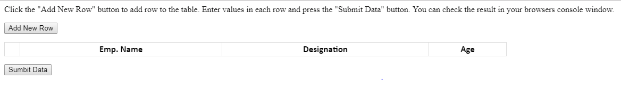

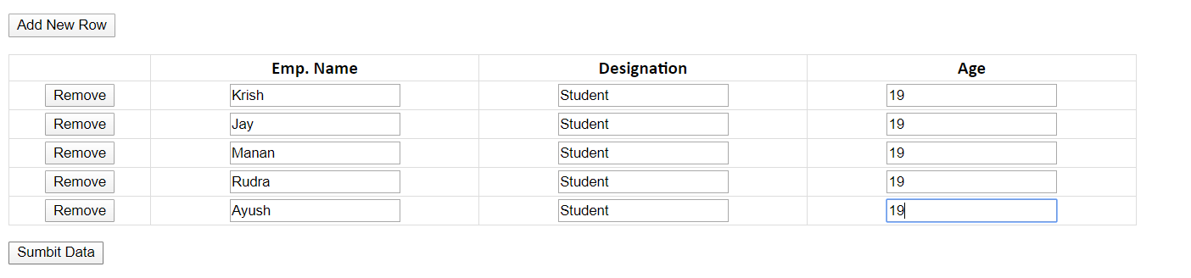

After removing the row:

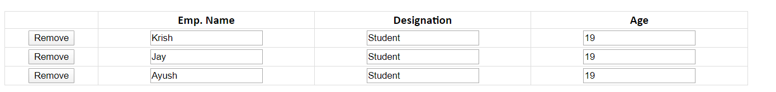

**CONCLUSION :**

In this practical we learn how to add and delete row and column using javascript.

**Part–6 ( BASICJQUERY )**

**PRACTICAL-1**

**AIM:** Implement following tasks using jQuery:

* Sliding page elements
* Hiding and Showing elements
* Fading elements
* Toggling elements
* Stopping effects

**PROGRAM CODE:**

<!DOCTYPE html>

<html>

<head>

<script src="https://ajax.googleapis.com/ajax/libs/jquery/3.4.1/jquery.min.js"></script>

<script>

$(document).ready(function()

{

$("#b2").click(function()

{

$("p").hide();

});

});

$(document).ready(function()

{

$("#b1").click(function()

{

$("p").show();

});

});

$(document).ready(function()

{

$("#p1").mouseenter(function()

{

alert("POP up!");

});

});

$(document).ready(function()

{

$("#flip").click(function()

{

$("#slide").slideToggle("fast");//both events are called alternatively

}); //if want to

call one at a time then either keep just one event or change

}); //callig

event for any one .

$(document).ready(function()

{

$("#flip").mouseover(function()

{

$("#slide").slideUp("slow");

});

});

$(document).ready(function()

{

$("input").focus(function()

{

$(this).css("background-color","cyan");

});

});

$(document).ready(function()

{

$("input").blur(function()

{

$(this).css("background-color","gray");

});

});

$(document).ready(function()

{

$("#bt1").click(function()

{

$("#d1").fadeIn(3000);

$("#d2").fadeIn(2000);

$("#d3").fadeIn(1000);

});

});

$(document).ready(function()

{

$("#bt2").click(function()

{

$("#d1").fadeOut(1000);

$("#d2").fadeOut(2000);

$("#d3").fadeOut(3000);

});

});

</script>

<style >

#slide

{

display: none;

}

#d1{display: none;} #d2{display: none;} #d3{display: none;}

</style>

</head>

<body>

<p>Click here to hide the text</p>

<p id="p1">Alert will be generated!!</p>

<button id="b1">SHOW</button>

<button id="b2">HIDE</button>

<p id="flip">Click to Slide content</p>

<p id="slide">Hello World</p><br>

NAME:<input type="text" name="NAME"><br> EMAIL:<input type="text" name="Email"><br>

<button id="bt1">Fade In</button>

<button id="bt2">Fade Out</button>

<div id="d1" style="height:50px; width:50px ;background-color:red"></div><br>

<div id="d2" style="height:50px; width:50px ;background-color:yellow"></div><br>

<div id="d3" style="height:50px; width:50px ;background-color:green"></div><br>

</body>

</html>

**OUTPUT:**

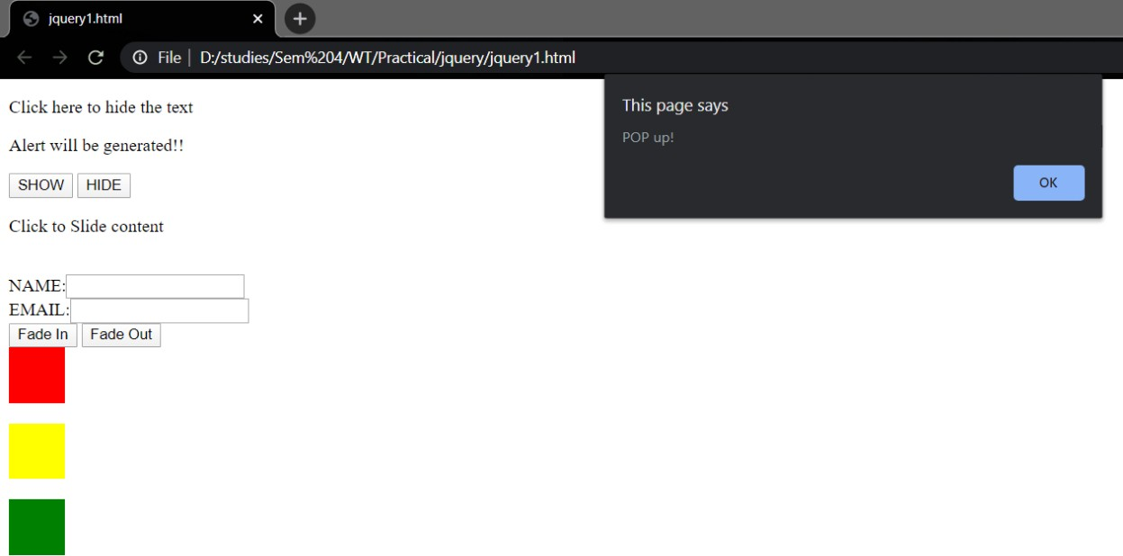

**PRACTICAL-2**

**AIM:** Create Animated Login form.

**PROGRAM CODE:**

//index.html

<!DOCTYPE html>

<html>

<head>

<meta charset="utf-8">

<title></title>

<link rel="stylesheet" href="style.css">

<script src="https://cdnjs.cloudflare.com/ajax/libs/jquery/3.4.1/jquery.min.js" charset="utf- 8"></script>

<link rel="stylesheet" href="https://use.fontawesome.com/releases/v5.3.1/css/all.css">

</head>

<body>

<div class="show-login-btn"><i class="fas fa-sign-in-alt"></i> Show Login Form</div>

<div class="login-box">

<div class="hide-login-btn"><i class="fas fa-times"></i></div>

<form action="index.html" class="login-form" method="post">

<h1>Login</h1>

<div class="txtb">

<input type="text">

<span data-placeholder="Username"></span>

</div>

<div class="txtb">

<input type="password">

<span data-placeholder="Password"></span>

</div>

<input type="submit" class="logbtn" value="Login">

<div class="bottom-text">

Don't have account? <a href="#">Sign up</a>

</div>

</form>

<script type="text/javascript">

$(".txtb input").on("focus",function(){

$(this).addClass("focus");

});

$(".txtb input").on("blur",function(){ if($(this).val() == "")

$(this).removeClass("focus");

});

</script>

<script type="text/javascript">

$(".show-login-btn").on("click",function(){

$(".login-box").toggleClass("showed");

});

$(".hide-login-btn").on("click",function(){

$(".login-box").toggleClass("showed");

});

</script>

</body>

</html>

//style.css

*{

margin: 0;

padding: 0;

text-decoration: none;

font-family: "montserrat",sans-serif; box-sizing: border-box;

}

body{

min-height: 100vh;

background-image: linear-gradient(120deg,#3498db,#8e44ad); margin: 0;

padding: 0;

}

.login-box{ position: absolute; top: 0;

left: -100%;

width: 100%;

height: 100vh;

background-image: linear-gradient(120deg,#3498db,#8e44ad); transition: 1s;

}

.login-form{ width: 360px;

background: #f1f1f1; height: 580px; padding: 80px 40px; border-radius: 10px; position: absolute; left: 50%;

top: 50%;

transform: translate(-50%,-50%);

}

.login-form h1{ text-align: center;

margin-bottom: 60px;

}

.txtb{

border-bottom: 2px solid #adadad; position: relative;

margin: 30px 0;

}

.txtb input{

font-size: 15px; color: #333; border: none; width: 100%; outline: none; background: none; padding: 0 5px; height: 40px;

}

.txtb span::before{

content: attr(data-placeholder); position: absolute;

top: 50%; left: 5px;

color: #adadad;

transform: translateY(-50%);

z-index: -1;

transition: .5s;

}

.txtb span::after{ position: absolute; width: 0%; height: 2px;

background: linear-gradient(120deg,#3498db,#8e44ad); transition: .5s;

}

.focus + span::before{ top: -5px;

}

.focus + span::after{ width: 100%;

}

.logbtn{ display: block; width: 100%; height: 50px; border: none;

background: linear-gradient(120deg,#3498db,#8e44ad,#3498db); background-size: 200%;

color: #fff; outline: none; cursor: pointer; transition: .5s;

}

.logbtn:hover{

background-position: right; transform: scale(1.1);

}

.bottom-text{ margin-top: 60px; text-align: center; font-size: 13px;

}

.hide-login-btn{ color: #000; position: absolute;

top: 40px;

right: 40px; cursor: pointer; font-size: 24px; opacity: .7;

}

.show-login-btn{ position: absolute; top: 50%;

left: 50%;

transform: translate(-50%,-50%); color: white;

border: 2px solid; padding: 10px; cursor: pointer;

}

.showed{ left: 0;

}

**OUTPUT: (I)**



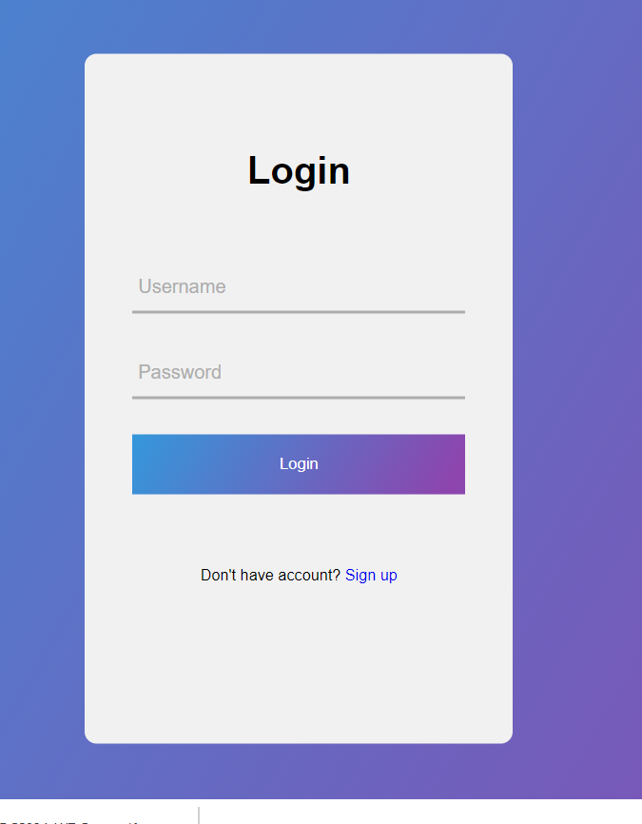

**PART–7 (BASIC) PHP**

**PRACTICAL - 1**

**AIM:** Installation and configuration of WAMP/XAMPP.

**STEPS:**

Step 1 : Install XAMPP on your machine.

How to inatall XAMPP on local machine

Step 2: Close the XAMPP.

Closing XAMPP to avoid collision between XAMPP and WAMP.

Step 3 : After installing XAMPP, install WAMP.

Install WAMP with default settings and options. You can install WAMP in any directory.

Step 4 : Now run WAMP for test.

Open your browser and write Localhost in url. You will find below screen.

Step 5 : Following steps for avoiding collision between XAMPP and WAMP.

This is a magic trick to run xampp and wamp on your local computer or server in network. It’s just changing your PORT for the WAMP apache server and mysql.

Step 6 : Changing PORT for WAMP apache server and mysql

By default apache listen on port 80 for the browsers and mysql listen on port 3306. Now, you need to change PORT no for apache and mysql for WAMPP. It’s need to do small change in http.conf file.

Step 7 : Changing PORT for WAMP apache server

Change in apache port to open config file. Basically location “C:\wamp\bin\apache\apache*.*.**\conf” where stars are basically the version number.

open config file in notepad OR any editor with administrative permission.

Now, within this file search “Listen 80” and change it with port no “Listen 8081“. We are just changing server listen port address. Now it will listen on port number 8081 instead of 80 port.After changing server port listen address. Now search “ServerName localhost:80” within this file. It need to change to “ServerName localhost:8081“.

Step 8 : Changing PORT for mysql

You must need to change port no of mysql for WAMP because XAMPP using specific mysql and your basic URL “localhost/phpmyadmin/” same for both WAMP and XAMPP. So, you need to differenciate both mysql.

for changing mysql port open the file location which is like this “C:\wamp\bin\mysql\mysql5.5.24“. open the file “my.ini” and find the line port = 3306 and replace it with port = 3307 this will enable your wampmysql to access along with xamppmysql due to different port address.

Step 9 : Accessing the wampmysql from wampphpmyadmin interface.

whenever we start phpmyadmin, we need to setup which server start first WAMP OR XAMPP. Overcome to this problem we need to make a small change in phpmyadmin interface code.

**IMPLEMENTATION:**

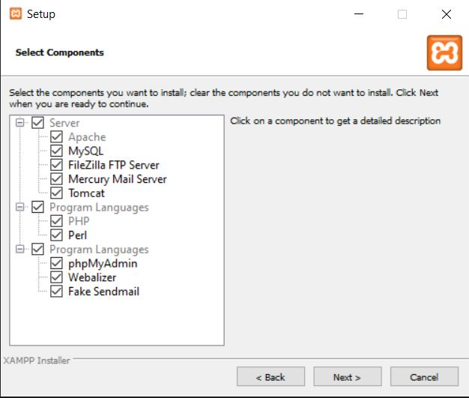

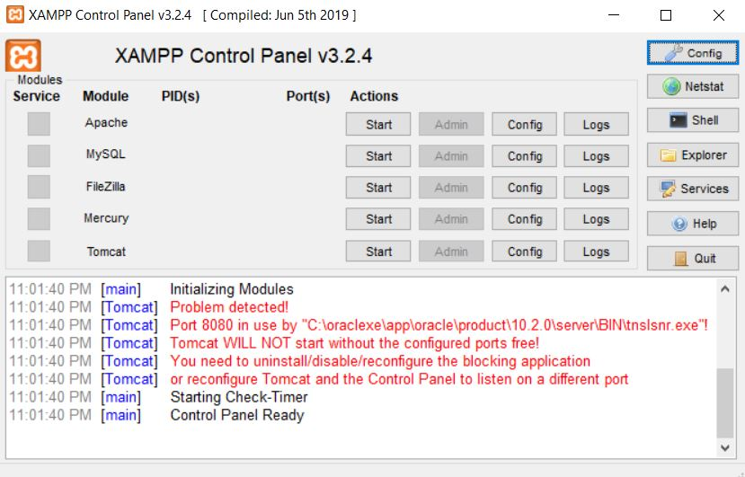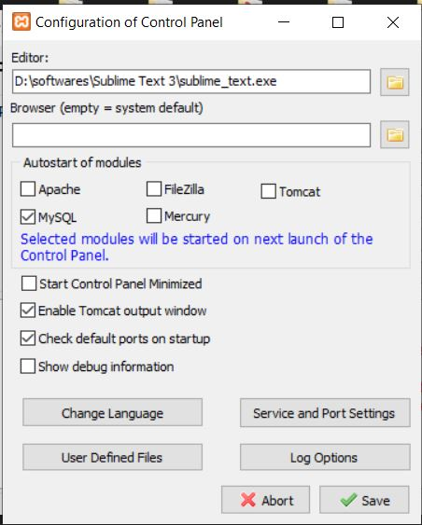

**CONCLUSION:**

In this practical we learn how to install and configure WAMP/XAMPP server.

**PRACTICAL – 2**

**AIM:** Study and demonstrate php syntax, data type, variable, function, array, super global variable and form.

**PROGRAM:**

<?php

$var = "heyy";

$num = 10;

echo $var;

$var="hello";

define('demo', "this is php");

?>

<!DOCTYPE html>

<html>

<head>

<title>php</title>

</head>

<body>

<h1><?php echo "Hello php<br>"; ?></h1>

<div><?php

$txt1 = "this is PHP<br>";

$x = 5;

$y = 5;

function display() {

echo "<br>Statement inside the functions..<br>";

}

echo "<h1>" . $txt1 . "</h1>";

print "5 + 5 = " .($x + $y). "<br>";

echo "<br>";

$fruits = array("apple","mango","watermelon");

var_dump($fruits);

echo "<br>";

display();

echo "<br>";

function displaystr($str) {

echo "$str <br>";

}

displaystr("function");

displaystr("with parameters");

$str="<h3>Global String</h3>";

function disGlobal()

{

echo $GLOBALS['str'];

}

disGlobal();

echo $_SERVER['PHP_SELF'];

echo "<br>";

echo $_SERVER['SERVER_NAME'];

echo "<br>";

echo $_SERVER['HTTP_HOST'];

echo "<br>";

echo $_SERVER['HTTP_USER_AGENT'];

echo "<br>";

echo $_SERVER['SCRIPT_NAME'];

?>

</div><br>

<form method="get" name="f1" action="form.php">

Name: <input type="text" name="name"><br>

E-mail: <input type="text" name="email"><br>

<input type="submit">

</form>

</body>

</html>

**OUTPUT:**

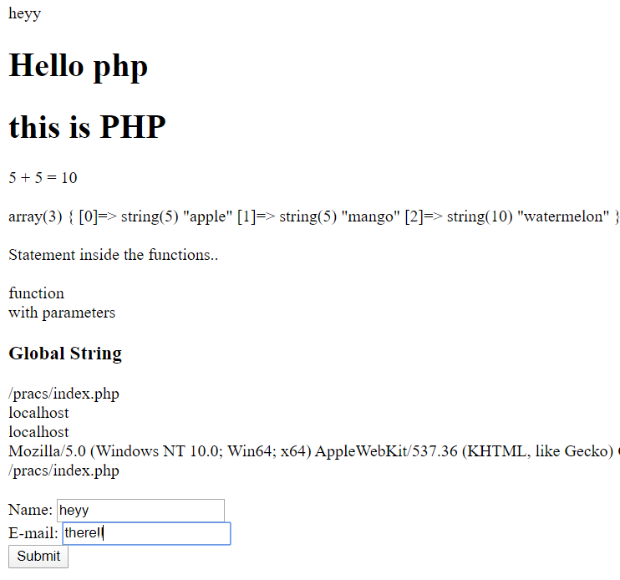

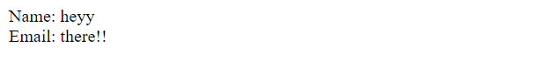

**CONCLUSION:**

In this practical we learnt about basic syntax, data type, variable, function, array, super global variable and form of PHP.

**PRACTICAL – 3**

**AIM:** Study and demonstrate mysqli connection and CRUID operations with php.

**PROGRAM:**

Index.php:

<?php

include_once("config.php");

$result = mysqli_query($mysqli, "SELECT * FROM users ORDER BY id DESC");

?>

<html>

<head>

<title>Homepage</title>

</head>

<body>

<a href="add.php">Add New User</a><br/><br/>

<table width='80%' border=1>

<tr>

<th>Name</th> <th>Mobile</th> <th>Email</th> <th>Update</th>

</tr>

<?php

while($user_data = mysqli_fetch_array($result)) {

echo "<tr>";

echo "<td>".$user_data['name']."</td>";

echo "<td>".$user_data['mobile']."</td>";

echo "<td>".$user_data['email']."</td>";

echo "<td><a href='edit.php?id=$user_data[id]'>Edit</a> | <a href='delete.php?id=$user_data[id]'>Delete</a></td></tr>";

}

?>

</table>

</body>

</html>

Add.php:

<html>

<head>

<title>Add Users</title>

</head>

<body>

<a href="index.php">Go to Home</a>

<br/><br/>

<form action="add.php" method="post" name="form1">

<table width="25%" border="0">

<tr>

<td>Name</td>

<td><input type="text" name="name"></td>

</tr>

<tr>

<td>Email</td>

<td><input type="text" name="email"></td>

</tr>

<tr>

<td>Mobile</td>

<td><input type="text" name="mobile"></td>

</tr>

<tr>

<td></td>

<td><input type="submit" name="Submit" value="Add"></td>

</tr>

</table>

</form>

<?php

if(isset($_POST['Submit'])) {

$name = $_POST['name'];

$email = $_POST['email'];

$mobile = $_POST['mobile'];

include_once("config.php");

$result = mysqli_query($mysqli, "INSERT INTO users(name,email,mobile) VALUES('$name','$email','$mobile')");

echo "User added successfully. <a href='index.php'>View Users</a>";

}

?>

</body>

</html>

Config.php:

<?php

$databaseHost = 'localhost';

$databaseName = 'crud_db';

$databaseUsername = 'root';

$databasePassword = '';

$mysqli = mysqli_connect($databaseHost, $databaseUsername, $databasePassword, $databaseName);

?>

Edit.php:

<?php

include_once("config.php");

if(isset($_POST['update']))

{

$id = $_POST['id'];

$name=$_POST['name'];

$mobile=$_POST['mobile'];

$email=$_POST['email'];

$result = mysqli_query($mysqli, "UPDATE users SET name='$name',email='$email',mobile='$mobile' WHERE id=$id");

header("Location: index.php");

}

?>

<?php

$id = $_GET['id'];

$result = mysqli_query($mysqli, "SELECT * FROM users WHERE id=$id");

while($user_data = mysqli_fetch_array($result))

{

$name = $user_data['name'];

$email = $user_data['email'];

$mobile = $user_data['mobile'];

}

?>

<html>

<head>

<title>Edit User Data</title>

</head>

<body>

<a href="index.php">Home</a>

<br/><br/>

<form name="update_user" method="post" action="edit.php">

<table border="0">

<tr>

<td>Name</td>

<td><input type="text" name="name" value=<?php echo $name;?>></td>

</tr>

<tr>

<td>Email</td>

<td><input type="text" name="email" value=<?php echo $email;?>></td>

</tr>

<tr>

<td>Mobile</td>

<td><input type="text" name="mobile" value=<?php echo $mobile;?>></td>

</tr>

<tr>

<td><input type="hidden" name="id" value=<?php echo $_GET['id'];?>></td>

<td><input type="submit" name="update" value="Update"></td>

</tr>

</table>

</form>

</body>

</html>

Delete.php:

<?php

include_once("config.php");

$id = $_GET['id'];

$result = mysqli_query($mysqli, "DELETE FROM users WHERE id=$id");

header("Location:index.php");

?>

**OUTPUT:**

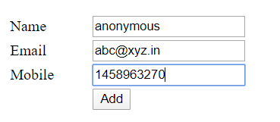



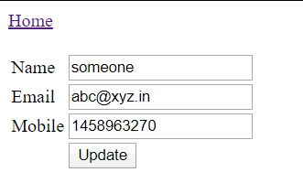



**CONCLUSION:**

In this practical we learnt about MySQL connection and CRUID operations with php.